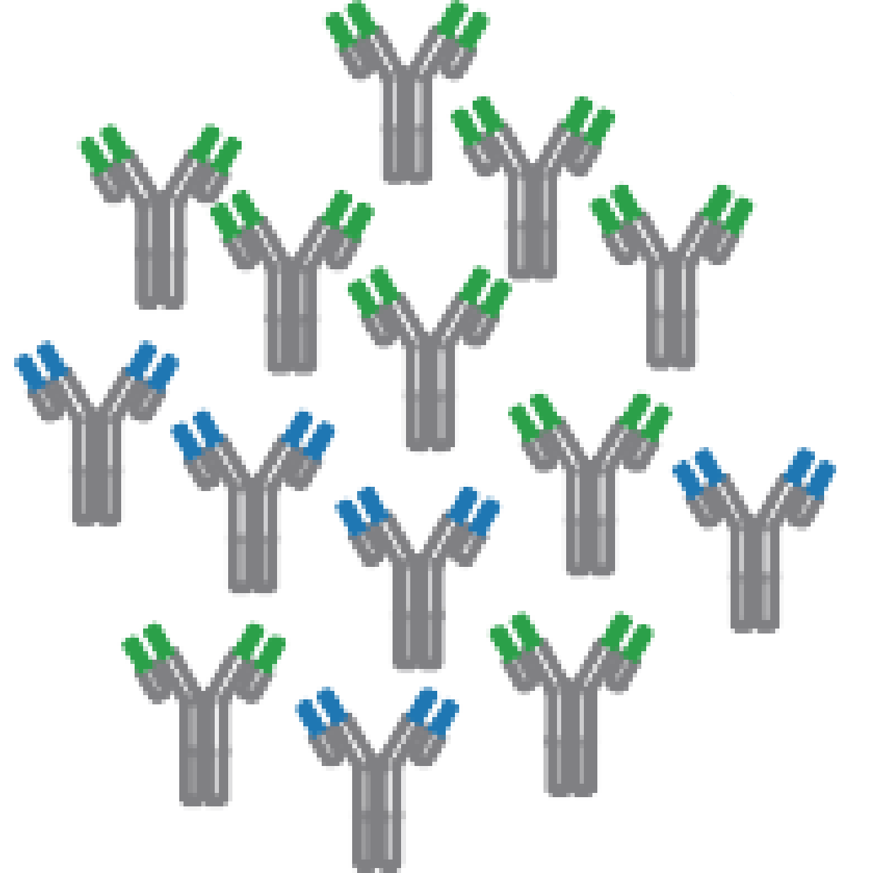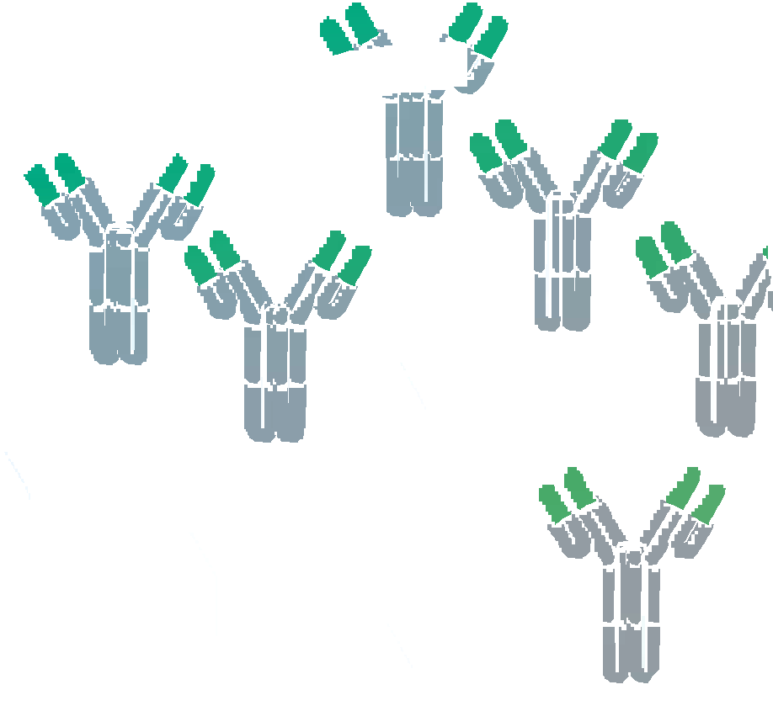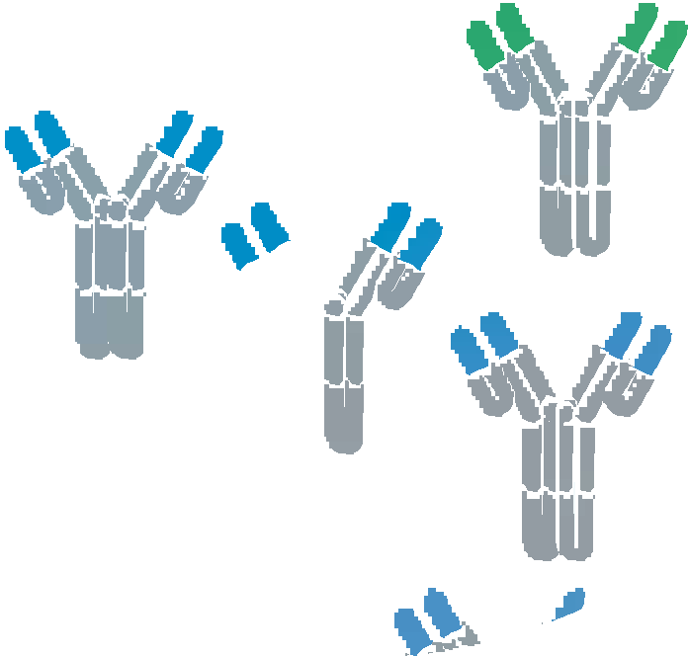

### Human plasma lgG1 repertoires are simple, unique, and dynamic

Albert Bondi, Max Hoek, Sem Tamara, Sebastiaan C. de Graaf, Weiwei Peng, Douwe Schulte, Danique

M.H. van Rijswijck, Maurits A. den Boer, Jean-Franc;:ois Greisch, Meri R.J. Varkila, Joos! Snijder, Olaf L. Cremer, Marc J.M. Bonten, Albert J.R. Heck

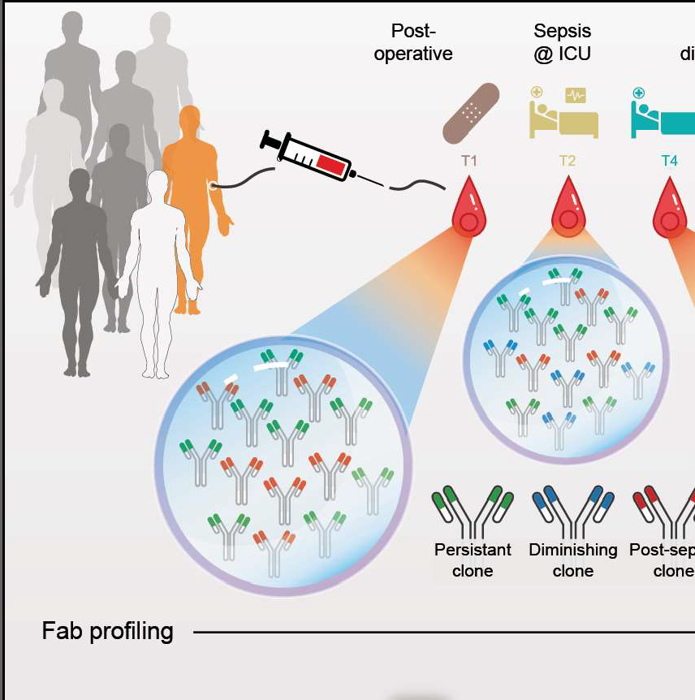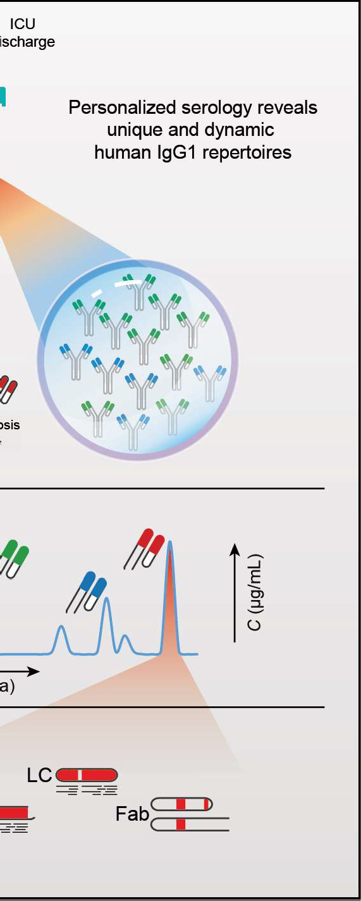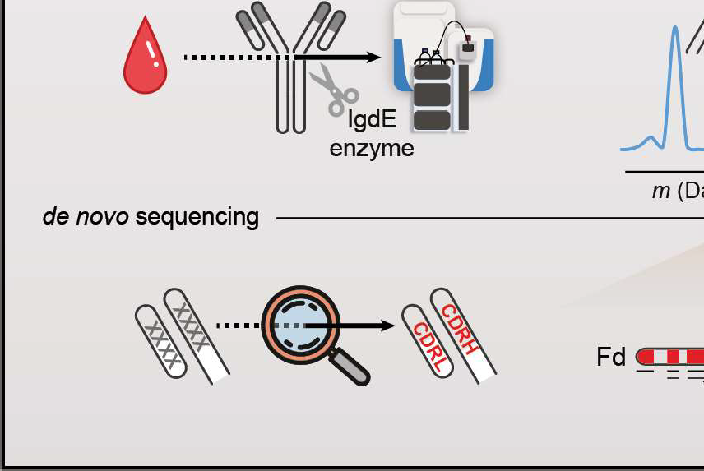

**This chapter is based on work in the following publication:**

***Cell Systems*** (2021), 12:1131-1143.eS, doi:10.1016/j.cels.2021.08.008

..,

**u** *Although humans can produce billions of lgG1 variants through recombination*

**1n** *and hypermutation, the diversity of lgG1 clones circulating in human blood*

*plasma has largely eluded direct characterization. Here, we combined sev­ eral mass-spectrometry-based approaches to reveal that the circulating lgG1 repertoire in human plasma is dominated by* a *limited number of clones in healthy donors and septic patients. We observe that each individual donor exhibits* a *unique serological lgG1 repertoire, which remains stable over time but can adapt rapidly to changes in physiology We introduce an integrative protein- and peptide-centric approach to obtain and validate* a *full sequence of an individual plasma lgG1 clone* de nova. *This lgG1 clone emerged at the on­*

*set of* a *septic episode and exhibited* a *high mutation rate (13%) compared with*

*the closest matching germline DNA sequence, highlighting the importance of*

de nova *sequencing at the protein level.*

# Introduction

HE human immune system protects us not only from threats posed by pathogens but also cancer and various other diseases. The immune response in health and disease is crucially dependent on each person's repertoire of immune cells, antibod­ ies, and other circulating plasma proteins. A detailed molecular view of these plasma components is crucial to understanding how they affect each individual's immune

3

T

response. lmmunoglobulins (lgs) represent some of the most important molecules in the human immune system. lg molecules consist of two identical heavy chains and two identical light chains, held together by a network of disulfide bridges. The heavy chains possess three (lgG, lgA, and lgD) to four (lgM and lgE) immunoglob­ ulin domains with large, conserved regions, which play a role in receptor binding and complement activation. Similar to the heavy chain, the C-terminal domain of the light chain is constant. On the other hand, for both heavy and light chain, the se­ quence of the N-terminal lg domains is hypervariable and contains the recognition­ determining parts, better known as complementarity-determining regions (CDRs), of the molecule. They are enclosed in the two fragment antigen-binding (Fab) arms of the antibody, consisting of the light chain and the N-terminal parts of the heavy chain (Fd). The variable regions of the antibody, in particular the CDRs, are optimized to recognize antigens by a process known as affinity maturation. The best antigen binders, modified through somatic recombination and hypermutation of numerous coding gene segment variants, give rise to the mature lgG secreting plasma B cells that produce the antibodies that end up in our circulation. The circulating antibodies, thus, consist of the fully matured heavy- and light-chain variable domain sequences that harbor the CDRs, joined by generally less sequence-variable framework regions (FR). Each unique combination of mature chains is called an lg clone. Considering the genes encoding the variable domain sections and the known genomic rearrange­ ments, somatic hypermutations, and post-transcriptional processes that join these

sections-resulting into the ultimate protein products-it has been estimated that in humans the theoretical molecular lg diversity may extend beyond 1015 (1). Not all theoretically possible lg clones will be expressed in the human body, since the num­ ber of B cells in a human body is several orders of magnitude lower (1-2 x 1011)

(2). Nevertheless, it has been assumed that the actual repertoire of circulating lgs is extremely large and diverse (3, 4). Recombinantly expressed clones (mainly lgG) have become a major class of therapeutics, used to fight multiple types of patholo­ gies such as cancers and various infectious diseases. Recent developments have moved the field toward using therapeutic monoclonal antibody (mAb) sequences de­ rived from human subjects instead of laboratory animals; this trend is exemplified by successful new treatments for Ebola (5-7) and COVID-19 (8). These therapeutic antibody sequences are inferred from genetic material recovered from patients that successfully overcame the disease. The ability to detect and identify individual ma­ ture lgG protein sequences directly from donor specimens would aid such efforts. To experimentally determine the lg repertoire, attempts have been made to sequence lg nucleic acids from bulk B cell populations or B cell subsets from single donors. These lgs are analyzed with high-throughput sequencing (lg-seq or Rep-seq) at the DNA or RNA level (9), resulting in datasets of tens to hundreds of thousands of unique reads of variable abundance (10). Unfortunately, these analyses at the level of DNA and RNA do not measure the actual antibodies of interest, and the presence of a cognate BCR sequence in the B cell population provides no information regarding abundance levels of the antibodies that end up in circulation. Alternatively, the chal­ lenge could be approached from the protein level, analyzing the lg repertoire present in circulation. The most abundant lg in human plasma is lgG, at a concentration of approximately 10 mg/ml during health (11, 12). Of the four lgG subclasses, lgG1 is the most abundant, accounting for more than 50% of all lgGs (13) in most people. Given the extremely high theoretical limits on lg diversity and the large number of experimentally determined variants, most researchers have refrained from analyzing

**3**

plasma antibodies directly at the protein level. It has been mostly assumed that it is impossible to detect any single lg clone against the expected background of thou­ sands to millions of other clones. However, in recent years, several attempts have been made to identify plasma lgs directly. G. Georgiou and colleagues should be considered pioneers. In their method (also referred to as lg-seq, but protein-based instead of solely gene-based), lgGs are purified from plasma, and tryptic lg peptides are characterized using liquid chromatography coupled online to tandem mass spec­ trometry (LC-MS/MS), focusing on the detection of lgG heavy-chain CDR3 peptides (14-18). Another recently developed proteomics approach uses LC-MS to profile intact light chains purified from plasma (19-24). In another report, profiling and se- quencing of intact Fabs was attempted, but the sensitivity was too low, and only a few sequence tags could be derived from separated light chains (25). In these ap- proaches, information about the heavy- and light-chain pairing is often lost, which is unfortunate as only the combined CDRs from both heavy and light chain provide the full complementarity against an antigen. Of note, in nearly all these studies, only a subset of plasma immunoglobulins recognizing and binding a specific antigen was targeted, or a mAb spiked into plasma was used as a model. Nevertheless, the re- markable observation was made that a person's plasma lg repertoire could be several orders less variable than assumed based on the available B cell repertoire and likely dominated by only a limited number of clones. Whether this observed number of lgGs is a consequence of the targeted analysis of antigen-specific lgGs or diseases with monoclonal lgG overexpression (gammopathy) remained unclear. Here, we intro- duce a sensitive and efficient approach for quantitative plasma lgG1 clone profiling. The method was applied to a sample set of two healthy control donors, as well as eight critically ill patients, from which sequential plasma samples were retrieved while developing nosocomial sepsis, experiencing a dramatic immunological change in a relatively short time span **(Figure 1A).** The application of our method revealed sev- eral important properties of the human plasma lgG1 repertoire: (1) the total lgG1

3

repertoire is dominated by a few dozen clones, but (2) is unique for each individual, and (3) single clones are differentially affected by physiological changes. Next, as proof of concept, we *de nova* sequenced a single plasma clone-that appeared at sepsis onset-directly from human plasma, only made possible by using iteratively a combination of protein-centric and peptide-centric proteomics. To validate the cor­ rectness of the derived *de nova* lgG1 sequence, we produced its recombinant mAb equivalent and compared its key structural features with the plasma clone. We fore­ see that this approach will unlock the potential of mass spectrometric analysis and identification of disease-responsive lgGs that may be directly evaluated and used as therapeutic agents, as they do already represent fully matured, fully human Abs.

3

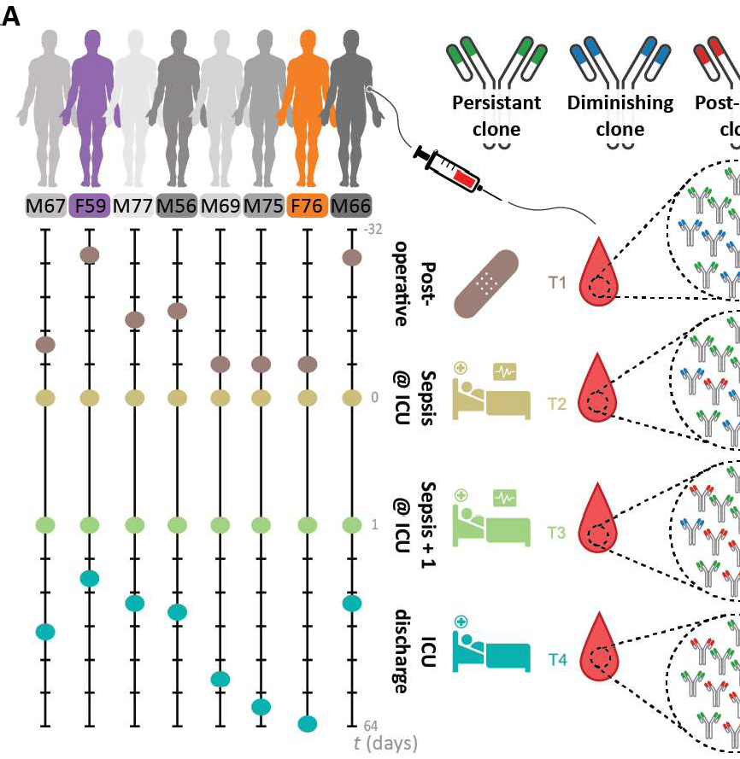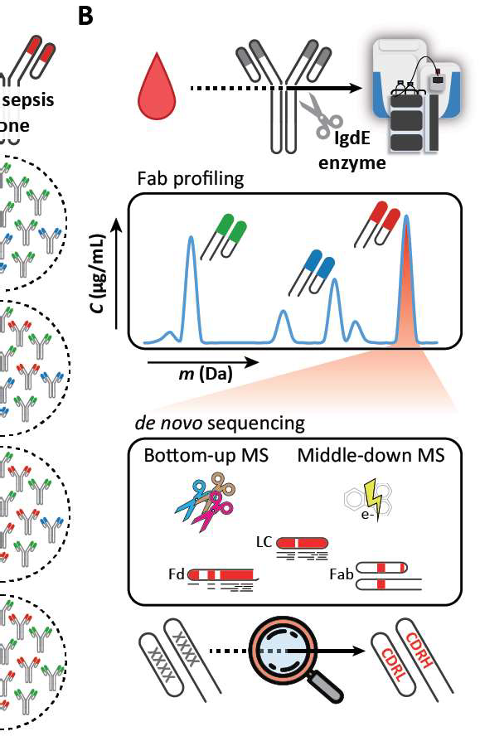

**Figure 1: Monitoring individual plasma lgG1 profiles.** (A) Longitudinal analysis of the lgG1 repertoire from sepsis patient plasma obtained at four time points, reveals its simplicity and clonal dynamics: some clones are fairly constant (green), some disappear (blue), whereas others appear over time (red). (B) The experimental approach taken involves lgG capturing from 10-100 µL of serum, followed by the specific enzymatic digestion of the lgG1 molecules in their hinge region, generating two identical Fab portions. All generated Fabs are collected and subsequently subjected to LC-MS analysis. The clonal repertoire is profiled, whereby each identified clone is characterized by its unique mass and retention time. A single post-sepsis clone from one of the patients (F59) was selected for *de nova* sequencing, combining protein­ and peptide-centric mass-spectrometry-based sequencing. The extracted full sequence of the plasma lgG1 was validated by analyzing, in a similar manner, a recombinant lgG1 analog of the plasma clone.

# Results

#### Mass-spectrometry-based Fab profiling of the human plasma repertoire

To chart and monitor the nature of the plasma lgG1 repertoire, we started our analysis

with 10 µL of plasma, derived from a single donor. From such a sample, we first cap­ tured all intact lgGs using affinity beads. Subsequently, the captured lgG molecules were digested using the highly specific lg degrading enzyme (lgdE), cleaving specifi­ cally lgG1'sat a defined site in the upper hinge region, resulting in the segregated Fe (that remains bound to the affinity beads) and two identical Fabs **(Figure 1B)** (26). We focused on the Fab fragments derived from the intact lgGs because this (1) con­ centrates the clonal signal since each lgG1 provides two identical Fab molecules, (2) results in more homogeneous mass profiles by removing the Fe portions that har­ bor two heterogeneous N-glycosylation sites, and (3) retains all hypervariable CDRs, which define the unique identity and antigen recognition of each clone. Following elution of the lgG1 Fabs, all these intact 45-53-kDa Fab molecules were subjected to reversed-phase LC-MS. All individual Fab fragments were subsequently charac­ terized by their distinctive mass and chromatography retention time. In our analyses, we spiked-in two monoclonal lgG1 antibodies **(Data 51,** mAbs #1 and #2) of known sequence at a defined concentration. These mAbs were used as internal standards for mass and retention time calibration and quantification of all the other distinctive plasma lgG1 clones. This also allowed us to calculate the precision and accuracy of retention time, mass, and quantification in our measurements as illustrated in **Fig­ ure 51A.** Using a mixture of six monoclonal antibodies **(Data 51)** spiked into a single­ donor plasma background, we furthermore observed linear relationship between (1) the quantity of mAbs that were spiked into the plasma sample, and (2) the quantity that is observed (R2 = 0.99, **Figure 51 B),** using a dilution/titration with 4,000, 800,

3

200, and 20 ng per mAb. Of note, no discrepancy was observed for the Fab glycosy­ lated mAb as compared to the other mAbs. To evaluate the repeatability (technical replicate and sample preparation replicate), the 100 most abundant plasma-derived clones in this sample were quantified in multiple replicates **(Figure S1C).** Finally, one of the samples was injected three times to serve as injection replicates **(Figure S1C,** #1). From all these validation experiments, we concluded that, by using the approach depicted here **(Figure 1),** the repertoire of Fab clones could be accurately and repro­ ducibly determined from as little as 10 µL of plasma obtained from a single donor at a single time point.

**3**

#### Plasma lgG1 repertoires are dominated by a few clones

Next, we analyzed in parallel a set of 32 plasma samples obtained from eight pa­ tients of the Dutch molecular diagnosis and risk stratification of sepsis (MARS) cohort **(Figure 1A; Data S2).** All these patients underwent major gastrointestinal surgery and subsequently developed an infectious complication (i.e., anastomotic leakage or pneumonia) resulting in sepsis. Plasma samples were obtained from the patients at four different stages: within 24 h of surgery when no signs of sepsis were present (sample T1; between t = -19 and t = -2 days), on two consecutive days after onset of sepsis (samples T2 and T3; t = 0 and t = 1 day), and upon intensive care unit (ICU) discharge, when the sepsis had been resolved (sample T4; between t = 3 and t = 61 days) **(Figure 1A).** In addition, to monitor the nature of the plasma lgG1 repertoire in healthy donors, we performed an identical analysis on two sets of three sequen­ tial healthy donor plasma samples, each collected roughly 1 month apart. In marked contrast to expectations of extensive lgG1 diversity, we observed that all the LC-MS profiles of lgG1 Fab molecules were dominated by just a few dozen peaks, both in the 32 sepsis plasma samples as well as in the six plasma samples of the healthy donors **(Data S1 and S2).** In each of the LC-MS runs, we could pick up distinctive

lgG1 signals of between 35 and 543 in abundance dominant clones (median 196; **Data 51)** that we distinguished by their masses in Dalton and retention times (RT) in minutes. Each detected clone was given a unique identifier: RT# mass- We found that the summed concentrations of the 30 most abundant lgG1 clones account for more than two-thirds of all lgG1 molecules detected from plasma (median 71.8%, range 47.3%-98.3%, **Data 51).** The full lists of detected clones are provided in **Data 51.** In addition, the deconvoluted mass plots (similar to **Figure 2C)** and the raw chro­ matograms supported by extracted chromatograms for all identified Fabs obtained in the LC-MS measurements are provided in **Data 52,** and one example of the actual raw mass spectrometry data of Fabs that we have analyzed is provided in **Data 53.**

3

Next, we looked at the cumulative mass distribution of all detected lgG1 Fabs in the plasma samples from all donors and at all time points. This cumulative mass distribution-representing more than 5,500 clones experimentally identified-resembled the expected mass distribution of over 130 million lgG1 Fabs constructed from these-

quences in the lmMunoGeneTics information system (IMGT) (27) database **(Figure 51 D),**

revealing that we profiled a representative lgG1 repertoire.

As can be seen in **Figure 51 D,** most Fab fragments exhibit masses between 46 and

49.5 kDa. However, we also did detect some higher Fab masses, which may be indicative of Fab glycosylation. The average mass of Fab glycans is estimated to be around 2,300 Da (28, 29). In two of our donors, annotated M66 and M77, we did detect relatively high levels of Fab glycosylation as shown for M66, time point 3, in **Figure 52A,** with the annotation of the putative Fab glycosylation annotated in **Figure 52B.** Still the Fab glycosylated clones represented just a few percent of the total abundance (2%-6% for donor M66 and M77). The fractional abundance of glycosylated Fabs in the other patients was between 0% and 1.86% (with a median of 0.295%) **(Figure 52C).** Also, in the two healthy donors, one displayed a fractional abundance of glycosylated Fabs of about 3% (F66H), whereas in the other donor this remained around 0.5% at all sampling time points. This fractional abundance is



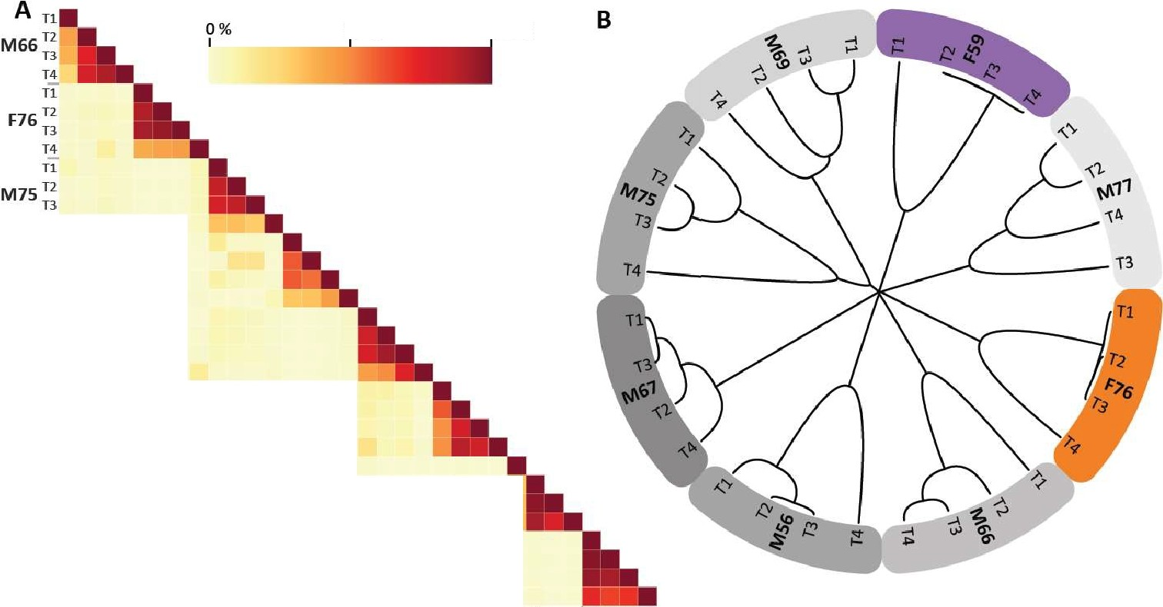

50%

100%

T4

Tl

M69n

T3

T4

Tl

M56n

T3

T!

Tl

M77n

T3

T4

Tl

•

F59 n

T3

T!

Tl

M67n

T3

T4

7n T2 T3 T41T1 T2 T3 T41n T2 T3 T4ln T2. T3 T4hl T2 T3 Hin T2T3T-ilTl T2 T3 T4 Tl T2 T3 *T4*

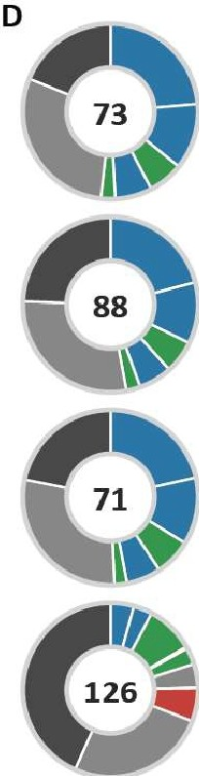M66 F76 **M75 M69 MSG M77** F59 **M67**

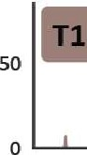C **0**

rnI **0** 0

I. I

••• I **M**

rl T2·---· - -

I

:,::;

, J -- -- -- -

21.31

•

21.32

•

47072:.5

46995.0

1 500**T3**,**-**I **- - - -- ------ -**

24.33

■

■

47972.6

■

22.94

46846.7

21.35

20.98

■

5 •

47279.0

47779.1

: I **l**I •**-111 i. - ,** l**l** · I·

* Other top 30 clones

46750 47000 47250 47500 47750 48000 48250

Mass (Da)

**E**

Residual clones

|  |  |  |  |  |
| --- | --- | --- | --- | --- |
| *if..,,* | - | JL | ' 21 3 5  ' 47279.0  A | zo.9g  jl_47779.1 |

**Figure 2:** Figure Legend on next page.

**Figure 2: Monitoring personalized plasma Fab repertoires reveals not only their simplicity and ex­ treme donor uniqueness but also longitudinal clonal variations within a single donor.** (A) Heatmap illustrating the degree of overlap between the detected lgG1 repertoires in all analyzed sepsis patient plasma samples. For each of the eight donors, four sampling times were available, and Fab profiles were measured by LC-MS analysis. Each LC-MS peak, exhibiting a unique mass and retention time pair, was considered a unique clone and annotated as RT # mass- The amount of Fab molecules, based on inten­ sity that is persistent, is quantified and shown as a percentage as indicated by the color bar. In between donors, the overlap is found to be on average 3%, whereas within a single donor at different time points the overlap was found to be in between 26% and 98%. (B) Hierarchical clustering of the Fab clonal repertoires based on correlation distance. The branch lengths depict the distance between the repertoires. Donors are colored as in **Figure 1A.** (C) Longitudinal deconvoluted Fab mass profiles of donor F76 at each of the four time points. Each peak represents a unique Fab at its detected mass and plasma concentration. The top 30 most intense Fab clones in each sample are colored reflecting the time points, the other clones are colored gray. Five peaks are highlighted with a box that is colored based on the longitudinal behavior of the Fab concentration in plasma (blue, diminishing clone; green, persistent clone; and red, post-sepsis clone), a magnified version of each of these Fab signals is shown in (E). (D) Pie charts portraying the total number and distribution of clones in donor F76 for each time point. The value within the chart displays the number of identified unique Fab molecules. The five most intense Fabs are colored based on longitudinal behavior, and their mass and retention time are depicted in the legend in order of abundance. (E) Mag- nified mass plots for each of the highlighted clones. The peaks are colored according to the time points, the surrounding border and sign indicate the longitudinal behavior and the top right shows the annotated clone ID.

**3**

substantially lower than would be predicted based on the IMGT database (~11% of these 130 million sequences carry at least one consensus N-glycosylation site) and lower than the ~17% described in literature (28, 29). However, our data reveal that the fractional abundance of glycosylated Fabs is also donor-dependent.

#### Plasma lgG1 repertoires are unique for each donor

Next, we compared the lgG1 Fab profiles between time points not only within a single donor but also between different donors. lnterindividual analyses showed that virtu­ ally none of the Fab IDs overlapped between individuals **(Figure 2A, Figure S3 and Figure S4A and B).** Also, hierarchical clustering based on clone IDs clusters each donor distinctively **(Figure 2B).** Thus, each donor has its own simple albeit unique lgG1 repertoire. However, within each individual, overlap between the measured lgG1 repertoires measured across time was found to be very high, even when the time span largely exceeded the average half-life of lgG1s **(Figure 2A-D and Fig­ ure S4).** A large portion of the most abundant lgG1s remains present throughout

the sampling window of up to 2 months, although we also observe a response in the lgG1 profile due to changes in the patient's physiology (discussed below). To exclude whether these findings were due to the severe physiological state of the eight septic patient donors, we performed a similar analysis on plasma of two healthy donors. In the absence of a dramatic immunological challenge, the lgG1 profiles, as obtained from the two healthy donors, show (1) a very high stability over time within individu­ als and (2) an interindividual overlap in uniquely RT- and mass-identified lgG1 clones near to zero **(Figure S4A and B).**

3

#### Longitudinal quantitative monitoring of single lgG1 clones

By spiking in two recombinant lgG1 mAbs at a known concentration to the plasma samples prior to sample preparation, we could provide additional absolute quantifi­ cation for the abundance of the detected lgG1s. The concentrations of the LC-MS­ detected endogenous lgG1 clones present in plasma ranged from less than 0.05 up to

>400 µg/ml (<300 pM up to >2.5 µM, median ~6.25 nM; **Data S1).** Monitoring sero­ logical lgG1 repertoires over time in patients who had undergone a septic episode, we observed several distinct quantitative patterns. The most recognizable patterns are highlighted in **Figure 2C-E.** There are lgG1 clones that become lower in concen­ tration over time **(Figure 2C-E,** blue boxes). Another category of lgG1 clones was undetectable in the plasma until post-sepsis but became abundantly present at T4 **(Figure 2C-E,** red boxes). Yet, another group of lgG1 clones was found to be rather persistent in concentration over all sampling moments **(Figure 2C-E,** green boxes). In healthy donors, the majority of clones were more persistent in concentration, al­ though some subtle changes could be observed for some clones.

##### Full *de novo* sequencing of an individual plasma lgG1 clone

From the data presented earlier, we can conclude that the plasma lgG1 repertoire of individual healthy and diseased donors is unique and dominated by a few dozen abundant clones. Next, we sought to identify the exact sequences of these clones to obtain further insight into their function and origin. Complete *de nova* sequencing of serological lgGs is notably difficult for several reasons. First, the inherent se­ quence hypervariability has so far proven to be highly challenging even when (per- sonalized) genome-based sequence templates are available. Second, *de nova* se- quencing of antibodies at the protein level by MS is hampered by the complex nature of lgG molecules, stemming from their multichain structure and the intricate network of disulfide bridges. Finally, although shotgun proteomics can be used to obtain (par- tial) sequences of purified mAbs (30-32), this becomes several orders of magnitude more difficult in a plasma background containing many lgG molecules of closely ho- mologous sequences. To tackle this challenge, we explored a hybrid and iterative ap- proach combining state-of-the-art peptide-centric (i.e., bottom-up) and protein-centric (i.e., middle-down) mass-spectrometric sequencing methods, using dedicated algo- rithms to mix-and-match the extracted proteomics-based sequencing data. As proof of concept, we attempted to fully sequence the light and heavy chain of a Fab de- rived from a single highly abundant lgG1 clone observed in donor F59. This donor showed a plasma lgG1 repertoire dominated by two clones in particular: 24.4 1 47,359.4

**3**

(average mass 47,359.4 Da, retention time 24.4 min) and 20-6 2 47,025_7 **(Figure 3A).**

We focused on the 24.4 1 47,359.4 clone, as this clone appeared exclusively after the onset of sepsis.

Following fractionation and selection of the 24·4 1 47,359.4 clone, we subjected this Fab to mass-spectrometry-based *de nova* sequencing, combining data from middle­ down and bottom-up proteomics **(Figure 1B).** The *de nova* sequence information from both approaches was used to first select several closely matching light- and

**3**

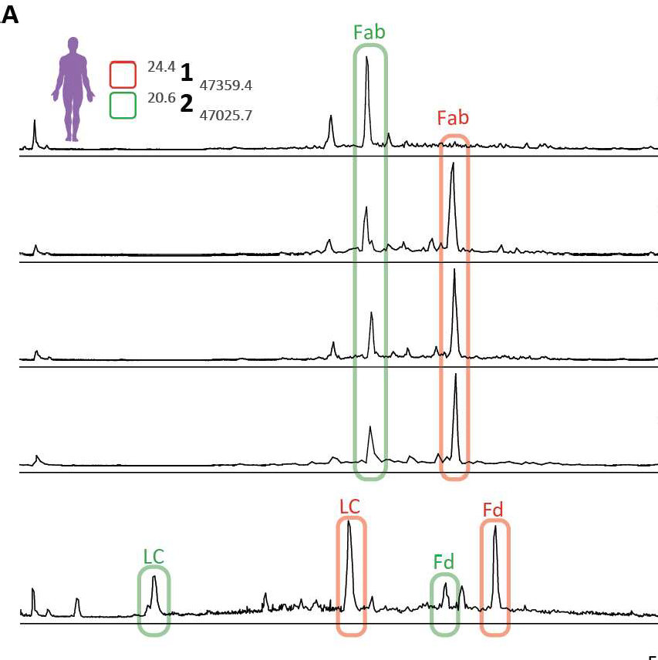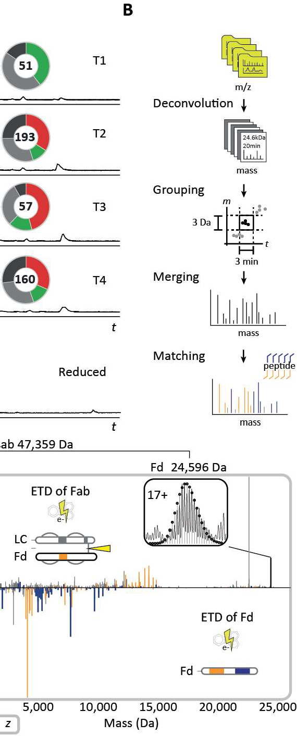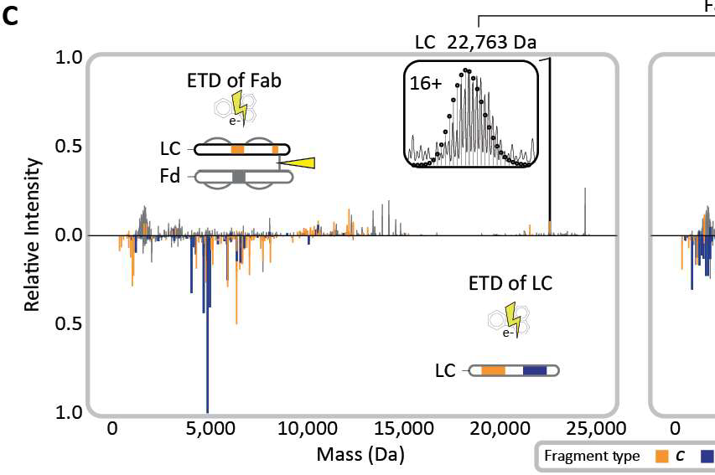

**Figure 3: Middle-down sequence characterization of the Fab clone** 24·4 **1** 47,359.4 **that becomes dom­ inant in the repertoire after the onset of sepsis-under reducing and non-reducing conditions.** (A) Reversed-phase LC-MS base peak profiles of the Fab repertoire detected in samples T1-4 from donor

F59 (top 4 profiles) reveal the dominance of a small number of clones, whereby especially clone 24.4 1

47_359_4 becomes dominant in abundance after the onset of sepsis. The LC-MS chromatogram of the re­ duced and denatured Fab repertoire from donor F59 at T3 is depicted in the bottom panel. The light chains (LCs) and the N-terminal portions of the heavy chains (Fd) of the two dominant clones are annotated with corresponding colors and chain names. All species highlighted in red were subjected to middle-down LC-MS/MS using ETD. (B) Data processing workflow to prepare middle-down ETD-MS/MS spectra for fragment matching and sequence-tag detection (see Methods section for details). (C) Deconvoluted ETD­ MS/MS spectra of the intact Fab (top spectra) and reduced LC and Fd fragments thereof (mirrored spectra) with the c/z-fragment ions annotated for the LC (left) and Fd (right). The isotopic envelopes of the most abundant charge states of the LC and Fd fragments released from the Fab upon ETD are depicted in the insets with theoretical isotope distributions of the corresponding chain sequences overlaid as black circles. Masses of the LC and Fd fragments and the cumulative mass of the Fab are indicated above the spectra. See also **Figure S6** for more detail on the fragment ions identified in these middle-down MS spectra.

heavy-chain templates from the publicly available IMGT database of lgG germline sequences **(Figure 55; Table 53 and Table 54).** Subsequently, the bottom-up and middle-down sequencing data and the measured intact accurate masses of the Fab, light chain, and Fd were used to refine the selected template sequences and ulti­ mately determine the mature sequence present in the donor, revealing discrepan­ cies between the germline and mature sequences. In the protein-centric approach, we performed electron transfer dissociation (ETD) on the intact Fab, as well as the light chain and Fd separately, obtained by reduction of the Fab molecule **(Figure 3A,** bottom trace). Several fragmentation scans obtained for the intact Fab, the sepa- rated light chain, and Fd were grouped and combined based on their unique precur- sor mass and retention time **(Figure 38).** The ETD mass spectra of the intact Fab yielded accurate masses of the light chain and Fd by cleavage of the interchain disul- fide bond, thus providing direct information about the light-chain-heavy-chain pairing **(Figure 3C,** top spectra). In addition, these ETD spectra yielded extended sequence tags, covering informative parts of the CDR3 and framework (FR) 4 regions of both Fab chains, in a similar manner as previously reported by performing ETD or ECO of intact lgG molecules (33-35). Complementary, ETD spectra of the separated Fab chains yielded partial sequence information for the FR1, CDR1, FR2, CDR2, and the constant region of the selected clone **(Figure 3C,** bottom spectra and **Figure 56).** Although our middle-down MS data provided valuable information about the clone of interest, they did not fully cover the sequence, primarily due to incomplete fragment formation and ambiguous sequence information obtained from the larger fragments. To further extend our sequencing attempt, we subjected the fraction containing the targeted lgG1 clone to enzymatic digestion, using in parallel four proteases: trypsin, chymotrypsin, thermolysin, and pepsin. The resulting peptides were analyzed by a bottom-up approach, using *de nova* sequencing algorithms for sequence annota-

**3**

tion (36). Although fractionated and enriched for the desired 24.4 1 47,359.4 clone, the bottom-up MS data also contained numerous peptides originating from co-isolated

plasma clones **(Figure 57),** which made it impossible to determine the correct se­ quence by solely using the bottom-up MS data. Nevertheless, by iteratively extending the sequence information from the middle-down MS approach with the *de nova* pep­ tides from the bottom-up MS approach, we ultimately were able to extract the most likely germline precursor of the targeted clone and, notably, its mature sequence by implementing various single-amino-acid mutations not present in the IMGT database **(Figure 4).**

3

In more detail, by using the IMGT database of germline sequences as input, the cu­ mulative MS evidence revealed that the analyzed lgG1 Fab carried a lambda light chain. This light chain originated from a combination of the immunoglobulin lambda (IGL) variable (V) 2-14*01 (IMGT/LIGM-DB: Z73664), IGLjoining (J) 2*01 (IMGT/LIGM­

DB: M15641), and IGL constant (C) 2*01 (IMGT/LIGM-DB: J00253) alleles. For the heavy-chain Fd portion, we determined that it was constructed from the immunoglob­ ulin heavy (IGH) V3-9*01 (IMGT/LIGM-DB: M99651), IGHJ5*01 (IMGT/LIGM-DB:

J00256), and IGHG1*03 (IMGT/LIGM-DB: Y14737) alleles and a diversity (D)-region, which substantially deviated from any reported germline D-region. Although initial identification resulted in just a partial sequence coverage, we could fill the gaps in the germline sequences using sequence tags from the middle-down MS and the *de nova* peptides from the bottom-up MS **(Figure 58 and Figure 59).** Eventually, our approach resulted in a complete and exact precursor mass match for the light and heavy chains, 100% sequence coverage in bottom-up MS, and near-complete an­ notation of all available fragments in the middle-down MS data. In this process, nu­ merous mutations had to be incorporated when comparing our data with the germline template sequences **(Figure 48 and C,** in red letters), revealing somatic hypermuta­ tion (SHM) of around 13% and 16% for the V gene of the light chain and the heavy chain, respectively. The level of confidence in each identified mutation site is based on several criteria, including support of a mutation by consecutive mass peaks in the middle-down MS retrieved sequence tags, the peptide scores and coverage depth

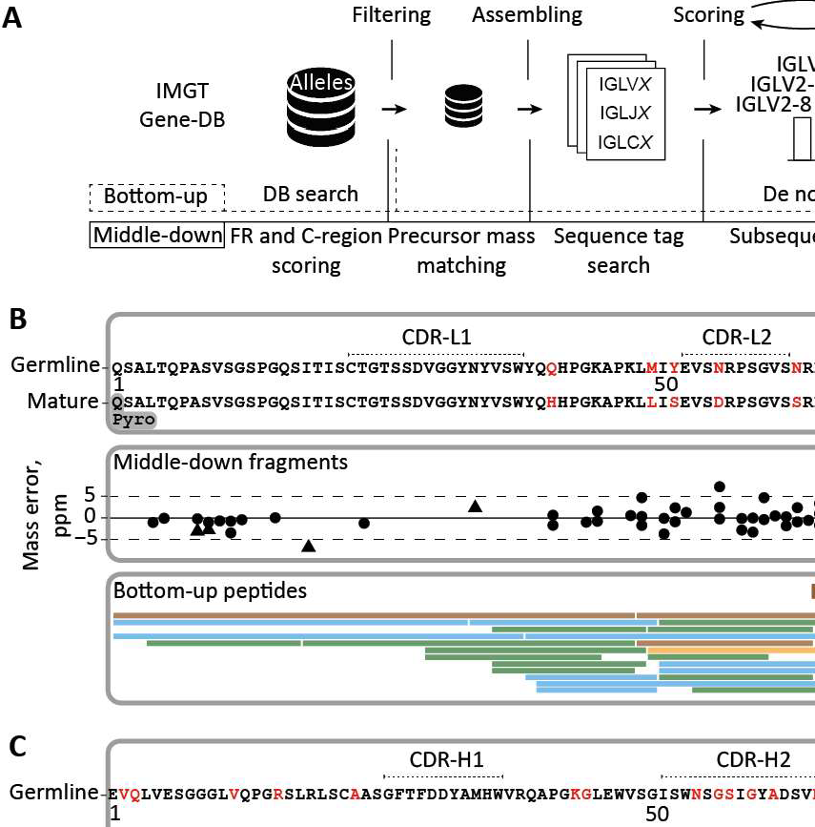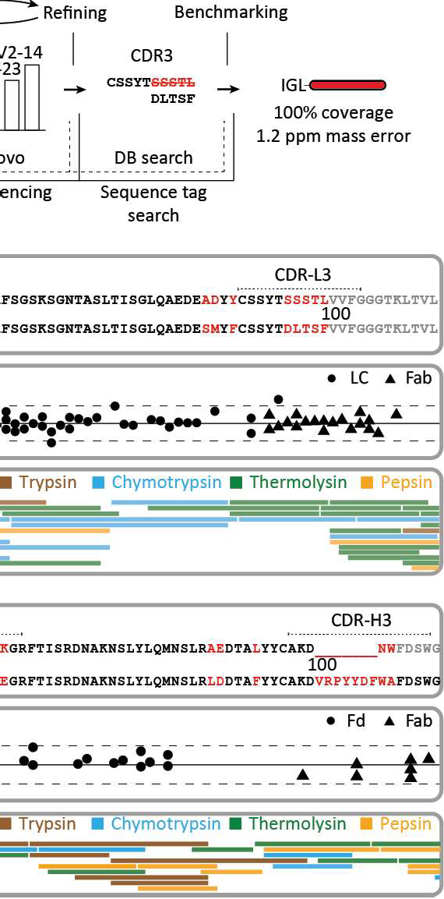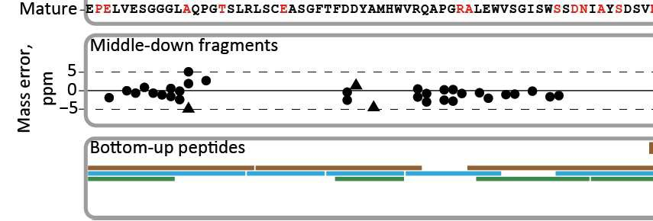

**3**

**Figure 4: Integrative *de novo* sequencing of the Fab clone** 24·4 **1** 47,359.4 **from donor F59 combining middle-down and bottom-up MS data.** (A) Data analysis pipeline displaying the key steps in the *de nova* sequencing, namely, filtering of the germline database of light- and heavy-chain sequences, assembling of selected allelic variants with mass constraints, scoring of the assembled sequences by using middle­ down MS data, iterative refining of the best scoring templates by using peptides in bottom-up MS, and benchmarking of the optimized mature sequences using data from both middle-down and bottom-up MS

analysis. (B) Alignment of the best matching germline IGLV amino acid sequence from the IMGT database (IGLV2-14*01) with the mature sequence that was determined for the light chain of the dominant clone (top box), the fragments from middle-down MS (middle box), and the peptides from bottom-up MS. (C) Alignment of the best matching germline IGHV amino acid sequence from the IMGT database (IGHV3- 9*01) with the mature sequence that was determined for the Fd of donor F59's clone 24.4 147,359.4 (top box), the fragments from middle-down MS (middle box), and the peptides from bottom-up MS. CDR regions in top panels of (B) and (C) were annotated with reference to the closest matching IMGT sequence. Amino acids that were determined to be different in the mature 24.4 1 47,359.4 sequence are highlighted in red.

in the bottom-up MS data as well as the frequency of amino acid occurrence at a given position in a pool of experimental and the germline lgG1 sequences **(Data 55; Figure 510).** Together this provides proof of concept that it is possible to *de nova* sequence lgG1s present in plasma. The definitive sequence assignment benefited largely from gathering multiple pieces of experimental evidence, notably (1) the ac­ curate mass of the Fab, (2) the highly accurate masses of the two individual chains comprising the Fab, (3) the *de nova* identified amino acid sequence reads, retrieved from the middle-down fragmentation of intact chains and intact Fab molecule, and

3

(4) the *de nova* identified amino acid reads from the-multiple proteases-based­ peptide-centric bottom-up approach.

##### Validation of the *de novo* sequencing-derived sequence

To validate the accuracy of the full *de nova* sequence of the 24.4 1 47,359.4 clone from donor F59, we generated a synthetic recombinant lgG1 clone based on the experimentally determined sequence. We used exactly the same procedures to se­ quence the recombinant mAb as applied to the plasma-obtained clone, including all the peptide- and protein-centric approaches. Since CDRs are the most critical and hypervariable regions of the antibody, we set out to find peptides in the two datasets covering these regions, so that we could directly compare their fragmentation spec­ tra. A direct comparison of tandem MS spectra of the CDR-spanning peptides from the donor clone and the recombinant mAb are presented in **Figure 5A and B,** cov­ ering parts of the light chain and Fd portion, respectively. Above the graphs, the de-nova-obtained sequence is shown with the annotated CDRs, whereby the purple lines indicate the selected peptides. In each panel, the MS/MS spectra obtained from peptides derived from the plasma clone of donor F59 and the recombinant mAb are shown, with the donor spectrum on top and the recombinant mAb spectrum mirrored below. Through visual comparison and as evidenced by the high correlation scores

ranging between 0.91 and 0.98, the spectra obtained for peptides originating from the recombinant clone were highly similar to the MS/MS spectra from the peptides derived from the plasma clone 24.4 1 47,359_4. The observed high similarity was not restricted to the *m/z* positions but was found to be also reflected into fragment ion intensities, which are quite sequence specific, thus presenting an additional layer of confidence.

Such a direct comparison of spectral features was extended to the middle-down anal­

3

ysis, used for obtaining sequence tags of the intact Fab **(Figure SC).** The intact re­ combinant Fab displayed a nearly identical retention time profile when compared with the plasma clone 24·4 1 47,359_4 Fab **(Figure SC,** left panel). Furthermore, both clone

24.4 1 47,359.4 and the recombinant mAb emerged with nearly identical charge distri­

butions **(Figure SC,** middle panel), whereby the slight differences in the distribution are likely due to the underlying background of co-eluting Fabs in the plasma-derived sample. Nevertheless, the masses detected for the two Fabs were identical, i.e., within a 20-ppm mass error. Moreover, when the intact Fabs were subjected to ETD, alike fragment masses and retention times for both the light chain and Fd were ob­ served, comparing the recombinant mAb with the plasma-derived clone. Finally, the generated lower mass fragment ions used for sequence-tag generation were also very similar **(Figure SC,** right panel). Likewise, the in-solution reduction of the Fabs revealed that there were no mass differences between the donor clone and recom­ binant mAb (light chain and Fd mass within 10 ppm). Based on all these data, we can conclusively state that the sequence of the plasma-derived clone 24.4 1 47,359_4 is identical to that of the recombinant mAb, with practically identical data observed at every step of our integrative *de nova* sequencing approach. This not only validates the accuracy of the lgG1 sequence that we obtained for clone 24.4 1 47,359.4 but also reinforces that the methodology presented here can be used to derive the correct full sequences from individual clones even when they are in a background of other plasma (highly sequence-homologous) lgG1 clones. Although this whole analysis

**3**

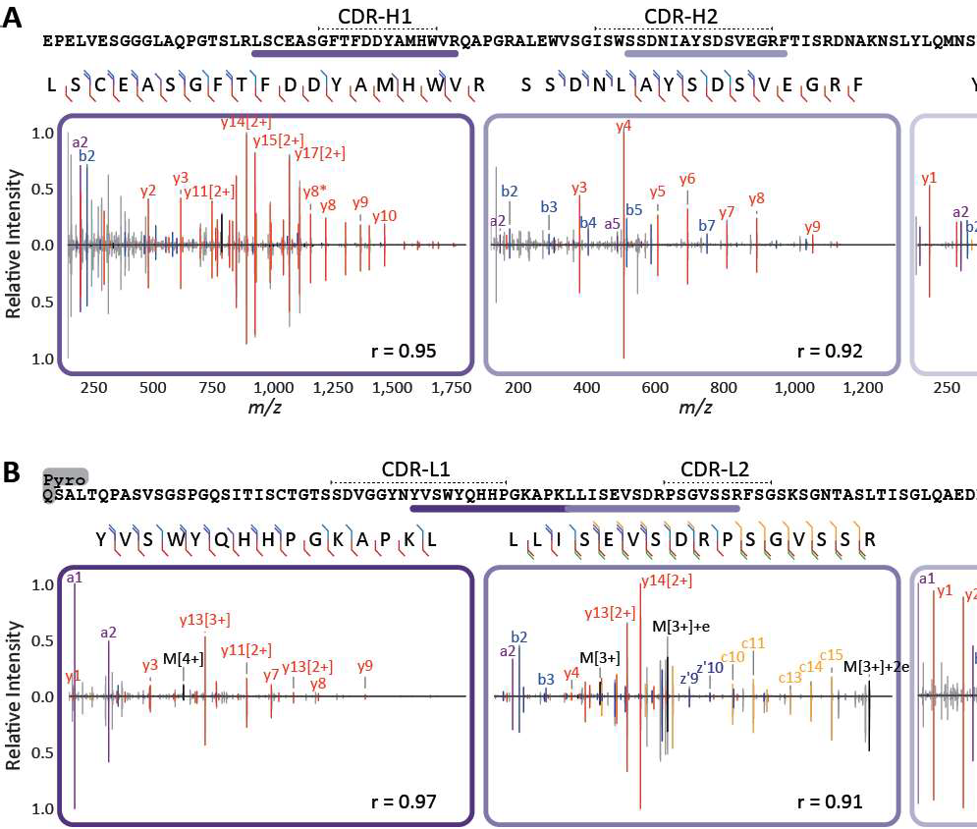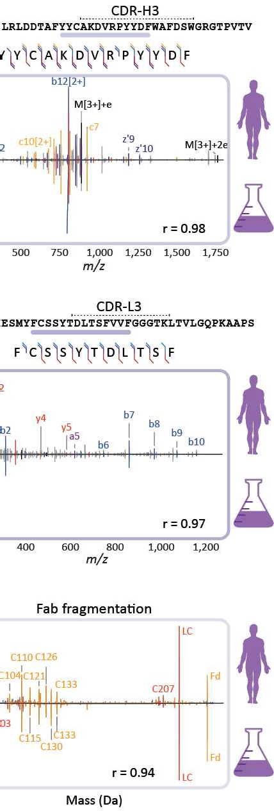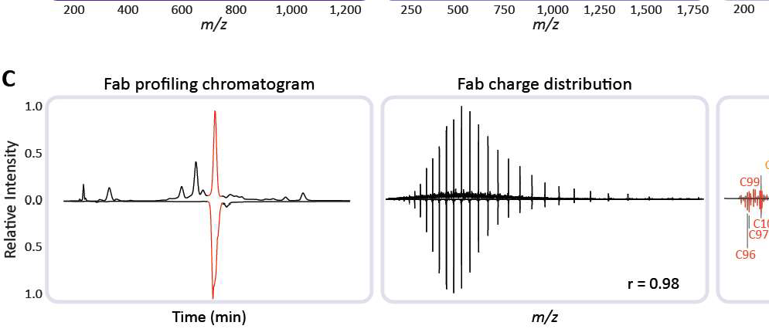

**Figure 5: Comparison of sequencing data for clone** 24·4 **1** 47,359_4 **of the donor F59, and the corre­ sponding recombinant mAb validates the correctness of the *de novo* sequencing approach.** (A) Peptide fragmentation spectra ofCDR-spanning peptides from the HC of the dominant 24.4 1 47_359.4 clone with, mirrored to each other, annotated spectra from the donor (top) and the recombinant lgG1 (bottom).

(B) Peptide fragmentation spectra of CDR-spanning peptides from the LC of the dominant 24.4 1 47_359.4 clone with, mirrored to each other, annotated spectra from the donor (top) and the recombinant lgG1 (bot­ tom). Spectra in (A) and (B) are annotated with a-ions in purple, b-ions in blue, y-ions in red, c-ions in orange, and z-ions in dark blue. Corresponding fragmentation maps are displayed above each spectral pair. (C) Comparison of the middle-down LC-MS/MS analysis of the 24.4 1 47,359.4 clone and the recombi­ nant lgG1. Shown are the base peak chromatograms (left panel), the charge-state distributions detected in MS1 of the Fab (middle panel), and the deconvoluted ETD fragmentation spectra for the donor (top) and recombinant (bottom) lgG (right panel). The Pearson correlation coefficients (r) calculated for all demon­ strated spectral pairs in (A), (B), and (C) are indicated at the bottom of each spectrum.

pipeline is still quite arduous, requiring manual validation throughout the process, we consider this proof of concept a major step forward and expect that further fine-tuning of the algorithms will enhance the throughput in the future.

# Discussion

The human body can make billions of different antibodies, stemming from the versa­ tile and complex recombination process, accompanied by additional somatic hyper­ mutations, helping us to adapt to a life-long exposure to various pathogens. Here, we demonstrate that it is feasible to profile the lgG1 repertoire of individual donors qualitatively and quantitatively by LC-MS, following the capturing of lgGs from plasma and analyzing the generated lgG1 Fab fragments. From this technical advance, one of the key observations we make is that in all studied donors at all time points, only a limited number of lgG1 clones dominate an individual's repertoire. In all donors, the 30 most abundant clones make up two-thirds of all detected circulating lgG1 molecules; in one donor just two clones contributed ~50% to the detected serum population of lgG1 molecules. The lgG1 clonal profiles are found to be unique for each donor. Within a donor, the profiles are highly similar across time, but they also adapt to physiological changes (e.g., sepsis). The mass-spectrometry-based approach requires only minute amounts of plasma (~10 µL) and does not involve labor-intensive enrichment protocols. We further show that specific lgG clones can be extracted from the plasma and analyzed in depth, ultimately leading to the mass­ spectrometry-based *de nova* sequencing of the whole Fab molecule. Therefore, one of the holy grails in proteomics, *de nova* sequencing of antibodies directly extracted from plasma, seems to be within reach. The ultimate mature sequence of 24.4 1 47,359.4 clone we sequenced here revealed that around 13% and 16% of the amino acids of the V-regions of light and heavy chains were different when compared with the clos­ est germline sequence match within the IMGT database. This number of mutations is

3

higher than the reported average (7%) for lgG1 heavy-chain variable regions, as de­ termined from RNA sequences (37). This suggests that DNA/RNA templates of the lgG sequences can be helpful, but for obtaining the correct sequence of the circulating clone, analyzing sequences at the level of the proteins will be essential. The ability to *de nova* sequence the whole Fab molecule is the result of combining, iteratively, middle-down and bottom-up proteomics data. An alternative strategy employed is to combine bottom-up proteomics data with BCR sequences using RNA sequencing of one donor to generate a database to match this donor's lg bottom-up proteomics data against (16). Although also very powerful, a recent application of this approach high­ lighted further the relevance of antibody sequencing at the level of proteins, when it was shown that for the six potent anti-HIV1 antibodies found by antigen-specific single-B-cell sequencing, only three could also be detected in circulation as lgG pro­ tein products (38). All these issues highlight the necessity of direct analysis of the serum lg repertoire at the protein level, as we now demonstrated here to be feasible. Longitudinal quantitative clonal profiling, as presented here, opens a myriad of future prospects, both fundamental and applied. It allows to advance our understanding of B cell biology and antibody dynamics. Historically, general observations have been made about antibody half-lives using a single dose of labeled antibodies (39) or by de­ termining the restoration of normal lgG levels following high-dose administrations of intravenous lgG (40). Through the method presented here, we can monitor the longi­ tudinal abundance of each single clone in the circulation and monitor how it responds to changes in the donor's physiology. Given the approximately 20-day lgG antibody half-life, it is expected that in the time span studied here (10-63 days), a decay in the concentration of clones would be detected. Indeed, we do observe several diminish­ ing clones as depicted in **Figure 2 and Figure S4.** However, other patterns are also observed, indicative of continuous production of the clone, even over a time window of two months. This is in line with previous reports on the presence of and production of antibodies by long-lived plasma cells, both in mice and humans (41-43). In addition,

**3**

persistence of autoreactivity has been reported before (44), as well as persistence of antibody clonotypes detected by CDR-H3 proteomics (17). From our data, we cannot derive information regarding (auto)reactivity, but the data do suggest that long-term stability is not exclusive to autoantibodies and is instead a common phenomenon. In summary, the *de nova* sequencing at the protein level of lgG clones circulating in plasma is shown here to be feasible. We demonstrate the synergistic power of com­ bining iteratively peptide- and protein-centric-based sequencing, which is capable of not only identifying the distinct alleles from which a clone originates but also its entire mature sequence. The work presented here is still quite a laborious proof of concept. Our aim for the future is quantitative monitoring and mass-spectrometry-based se- quencing of multiple serum immunoglobulins directly at the protein level, i.e., as they appear in circulation and function in the human immune response.

**3**

#### Experimental model and subject details

**Human subjects**

We obtained longitudinal plasma samples from the Molecular Diagnosis and Risk Stratification of Sepsis (MARS) biorepository (ClinicalTrials.gov identifier NCT01905033), for which subjects had been included in the mixed ICU of a tertiary teaching hospital

in the Netherlands (University Medical Centre Utrecht, Utrecht) since January 2011. Donors were enrolled via an opt-out consent method approved by the institutional review board of the UMC Utrecht (IRB no. 10-1056C). Daily leftover EDTA plasma (obtained from blood drawn during routine care) was stored at -80 °C until use. For the current study, we included eight patients with esophageal or gastroesophageal junction cancer who underwent an elective esophagectomy and gastric pull-through procedure and had subsequently developed an infectious complication (i.e., anas­ tomotic leakage or pneumonia). These patients were all admitted to the Intensive Care Unit on two occasions. The first admission concerned routine observation after

elective resection followed by an uncomplicated ICU stay of fewer than 2 days. All patients were subsequently readmitted to the ICU due to sepsis. For all episodes of sepsis, microbiological cultures were obtained either before or during ICU readmis­ sion, and clinical infection was adjudicated highly plausible according to pre-defined criteria (45). Furthermore, all infectious episodes met SIRS criteria and had a Se­ quential Organ Failure Assessment (SOFA) score 2, thus fulfilling current Sepsis-3 definitions (46). All patients were ultimately discharged from ICU in a clinically stable condition. We analyzed plasma samples obtained at four well-defined time points: within 24 hours of surgery when no signs of sepsis were present (sample T1), on two consecutive days after onset of sepsis (samples T2 and T3), and upon ICU discharge following resolution of sepsis (sample T4). Patient characteristics are summarized in **Data 52.** All patients had been treated with neoadjuvant chemoradiotherapy prior to surgery. None of the patients received treatment with immunoglobulins or mon­ oclonal antibodies either prior to or during ICU admission. In addition, longitudinal EDTA plasma samples from two healthy Caucasian donors were purchased from Precision Med (Solana Beach, CA, US). The samples were part of the 'Normal Con­ trol Collections', protocol number 7005-8200. These donors were selected having similar characteristics as the sepsis donors regarding age and gender.

3

#### Method details

###### Plasma lgG purification and Fab generation

The lgG purification and generation of Fabs was adapted from an earlier published protocol (47). The FcXL affinity matrix used in the workflow, which binds to the CH3 domain of the lgG constant region, has recently been shown not to provide a bias regarding analysis of the Fe glycosylation residing in the CH2 domain (48). Mobicol spin filters were assembled according to the manufacturer's instructions and placed in 2 ml Eppendorf tubes. Then 20 µL FcXL affinity matrix slurry was added to the

spin filter, followed by three washing steps with 150 µL PBS, in which the liquid was removed by centrifugation for 1 min at 1000 x g. Two additional washing steps with 150 µL were performed. After washing, the 2 ml tube was replaced by a 1.5 ml tube. The affinity matrix was resuspended in 150 µL PBS, and 10 µL plasma was added. Furthermore, 1 µL of a solution containing two known mAbs at 200 µg/ml each was added, corresponding to 20 µg/ml when calculated to the plasma concentration. The samples were then incubated, under shaking conditions for one hour at room temper­ ature. After the incubation, the flow-through was collected, and the affinity matrix with bound lgGs was washed four times with 150 µL PBS. Finally, 50 µL PBS containing 100 U of the lgdE (FabALACTICA; Genovis AB, Lund, Sweden) protease was added before incubating on a thermal shaker at 37 °C for >16 hours. After the incubation, 10 µL of Ni-NTA beads were added to bind and remove the His-tagged protease, where- after the samples were incubated for an additional 30 minutes. The flow through after centrifugation contained the Fab fragments generated from lgG1.

3

**Method optimization and validation using a mixture of recombinant mAbs**

In an array of experiments, we optimized and validated the robustness and accu­ racy of our lgG1 capturing approach, the generation of the Fab fragments and the analysis of the Fab LC-MS profiles. Therefore, we prepared a mixture of six lgG1 monoclonal antibodies, including the two spiked into every plasma sample subse­ quently analyzed. For the method optimization the 6 recombinant mAbs were added to the plasma of a single donor in different quantities: 4,000, 800, 200, 20, 2, or

0.5 ng per mAb. The mAbs used were trastuzumab (Roche, Penzberg, Germany), alemtuzumab (Genmab, Utrecht, The Netherlands), the Fab glycosylated cetuximab, rituximab, bevacizumab, and infliximab (Evidentic, Berlin, Germany). Fab sequences and theoretical masses of these mAbs, including the most abundant cetuximab gly­ coforms, are shown in **Data S1.** All these samples were injected once, except for the 200 ng sample which was injected three times to provide additional injection repli-

cates.

###### LC-MS(/MS)

Reversed-phase liquid chromatography was performed by using a Thermo Scientific Vanquish Flex UHPLC instrument, equipped with a 1 mm x 150 mm MAbPac RP analytical column, directly coupled to an Orbitrap Fusion Lumas Tribrid (Thermo Sci­ entific, San Jose, CA, USA) or Q Exactive HF-X mass spectrometer (Thermo Fisher

3

Scientific, Bremen, Germany). The column preheater, as well as the analytical col­ umn chamber, were heated to 80 °C during chromatographic separation. Both sam­ ples, either containing intact Fabs or separate Fab chains, were separated over 62 min at a 150 µUmin flow rate. Gradient elution was achieved by using two mobile phases A (0.1% HCOOH in Milli-Q) and B (0.1% HCOOH in CH3CN) and ramping up B from 1O to 25% over one minute, from 25 to 40% over 55 min, and from 40 to 95% over one minute. MS data were collected with the instrument operating in Intact Protein and Low Pressure mode. Spray voltage was set at 3.3 kV, capillary tempera­ ture 350 °C, probe heater temperature 100 °C, sheath gas flow 35, auxiliary gas flow 10, and source-induced dissociation was set at 15 V. The electrospray voltage was applied after 2 min to prevent the salts in the sample from entering the MS. Intact Fabs were recorded with a resolution setting of 7,500 (@ *m/z* 200) in MS1, which allows for better detection of charge distributions of the large proteins (> 30 kDa)

(49). Separate Fab chains were analyzed with a resolution setting of 120,000 (@ *mlz* 200) in MS1, which allows for more accurate mass detection of smaller proteins (< 30 kDa). MS1 scans were acquired in a range of 500-3,000 Th with the 250% AGC target and a maximum injection time set to either 50 ms for the 7,500 resolu­ tion or 250 ms for the 120,000 resolution. In MS1, 2 µscans were recorded for the 7,500 resolution and 5 µscans for the 120,000 resolution per scan. Data-dependent mode was defined by the number of scans: single scan for intact Fabs and two scans for separate Fab chains. In both cases, MS/MS scans were acquired with a resolu-

tion of 120,000, a maximum injection time of 500 ms, a 1,000% AGC target, and 5 µscans averaged and recorded per scan. The ions of interest were mass-selected by quadrupole in a 4 Th isolation window and accumulated to the AGC target prior to fragmentation. The electron-transfer dissociation (ETD) was performed using the following settings: 16 ms reaction time, a maximum injection time of 200 ms, and the AGC target of 1e6 for the ETD reagent. For the data-dependent MS/MS acquisi­ tion strategy, the intensity threshold was set to 2e5 of minimum precursor intensity. MS/MS scans were recorded in the range of *m/z* = 350-5,000 Th using high mass range quadrupole isolation.

3

**Clonal profiling data analysis**

Masses were retrieved from the generated RAW files using BioPharmaFinder 3.2 (Thermo Scientific). Deconvolution was performed using the ReSpect algorithm be­ tween 5 and 57 min using 0.1 min sliding window with 50% offset and a merge tol­ erance of 50 ppm, with noise rejection set at 95%. The output mass range was set at 10,000 to 100,000 with a target mass of 48,000 and mass tolerance of 30 ppm. Charge states between 10 and 60 were included, and the Intact Protein peak model was selected. Further data analysis was performed using Python 3.8.10 (with li­ braries: Pandas 1.2.4 (50), Numpy 1.20.2 (51), Scipy 1.6.2 (52), Matplotlib 3.3.4 (53) and Seaborn 0.11.1). Masses of the BioPharmaFinder identifications (components) were recalculated using an intensity weighted mean considering only the most in­ tense peaks comprising 90% of the total intensity. Furthermore, using the data of two spiked-in mAbs (trastuzumab and alemtuzumab) a mass correction was applied based on the difference between the calculated and observed mAb masses, and similarly, a retention time alignment was applied to minimize deviation between runs. Components between 45,000 and 53,000 kDa with the most intense charge state above *m/z* 1,000 and score 40 were considered Fab portions of lgG clones. The clones were matched between runs using average linkage (unweighted pair group

method with arithmetic mean UPGMA) L00 distance hierarchical clustering. Flat clus­ ters were formed based on a cophenetic distance constraint derived from the mass and retention time tolerance. These tolerances were defined as three times the stan­ dard deviation of the mAb standards, which were 1.4 Oa and 0.8 min, respectively. Clones within a flat cluster were considered identical between runs.

###### Peptide-centric (bottom-up) *de novo* sequencing

3

Clones of interest were captured through fraction collection using the same chro­ matography setup used for LC-MS profiling. Samples were dried under vacuum and resuspended in a 50 mM ammonium bicarbonate buffer. To boost signal intensity, the fractions were pooled across the time points. Samples were equally split for diges­ tion with four proteases. For digestion with trypsin, chymotrypsin and thermolysin, a sodium deoxycholate (SOC) buffer was added to a total volume of 80 µL, 200 mM Tris pH 8.5, 1O mM tris(2-carboxyethyl)phosphine (TCEP), 2% (w/v) SOC final con­ centration. For pepsin digestion, a urea buffer was added to a total volume of 80 µL, 2M Urea, 1O mM TCEP. Samples were denatured for 1O min at 95 °C followed by reduction for 20 min at 37 °C. Next, iodoacetic acid was added to a final concentration of 40 mM and incubated in the dark for 45 min at room temperature for alkylation of free cysteines. Then for trypsin, chymotrypsin and thermolysin 50 mM ammonium bicarbonate buffer was added to a total volume of 100 µL. For pepsin 1 M HCI was added to a final concentration of 0.04 M. 0.1 µg of each protease was added and incubated for 4 hours at 37 °C. After digestion 2 µL HCOOH was added to precipitate the SOC. SOC was removed by centrifugation for 20 min at max speed (20,817 x g) after which the supernatant was moved to a new tube. Samples were desalted by Oasis HLB (Waters Corporation, Millford, MA, USA) following a 5-step protocol.

1) Sorbent was wetted using 2x 200 µL CH3CN, 2) followed by equilibration with 2x 200 µL water/10% HCOOH. 3) The sample was loaded and 4) washed with 2x 200 µL water/10% HCOOH. 5) Finally, the sample was eluted using 2x 50 **µL** water/50%

CH3CN /10% HCOOH and dried down by vacuum centrifuge. Prior to MS analysis samples were reconstituted in 2% HCOOH.

**LC-MS/MS** Data acquisition was performed on the Orbitrap Fusion Tribrid Mass Spectrometer (Thermo Scientific, San Jose, CA, USA) coupled to UHPLC 1290 sys­ tem (Agilent Technologies, Santa Clara, CA, USA). Peptides were trapped (Dr. Maisch Reprosil C18, 3 µm, 2 cm x 100 µm) prior to separation (Agilent Poroshell EC-C18, 2.7 µm, 500 mm x 75 µm). Trapping was performed for 10 min in solvent A (0.1% HCOOH in Milli-Q), and the gradient was as follows: 0-13% solvent B (0.1% HCOOH in 80% CH3CN) over 5 min, 13 - 44% solvent B over 65 min, 44 - 100% solvent B over 4 min, and 100% B for 4 min (flow was split to achieve the final flowrate of ap­ proximately 200 nl/min). Mass spectrometry data was collected in a data-dependent fashion with survey scans ranging from 350-2,000 Th (resolution of 60,000 @ *m/z* 200), and up to 3 sec for precursor selection and fragmentation with either stepped higher-energy collisional dissociation (HCD) set to [25%, 35%, 50%] or electron trans- fer dissociation (ETD), used with charge-normalized settings and supplemental ac- tivation of 27%. The MS2 spectra were recorded at a resolution of 30,000 (@ *m/z* 200). The AGC targets for both MS and MS2 scans were set to standard within a maximum injection time of 50 and 250 ms, respectively.

3

**Data analysis** Raw LC-MS/MS data were processed using PEAKS X software (Bioin­ formatics Solutions Inc., Waterloo, ON, Canada) for *de nova* sequencing of peptides. The following parameters were used for *de nova* sequencing: parent mass error tol­ erance - 12 ppm, fragment mass error tolerance - 0.02 Da, max number of variable PTMs per peptide - 3. Fixed modifications: Carboxymethyl; variable modifications: Oxidation (HW), Oxidation (M), Pyro-glu from E, Pyro-glu from Q, Carboxymethyl (KW, X@N-term), and Carbamylation. Resulting *de nova* peptide tables were ex­ ported as.csv files and used for filtering of the IMGT database and determination of

the mature 24.4 1 47359.4 clone sequences.

###### Protein-centric (middle-down) *de novo* sequencing

Fab samples were prepared without treatment as well as under denaturing and re­ ducing conditions for analysis of intact Fab and separate Fab chains, respectively. The latter were denatured and reduced in 10 mM TCEP at 60 °C for 30 min prior to LC-MS/MS analysis. Approximately 2-5 µg of each sample was injected for a single middle-down LC-MS(/MS) experiment using the parameters described above.

3

**Data analysis** Full middle-down MS spectra were deconvoluted with either Xtract

(54) or Respect (Thermo Fisher Scientific, Bremen, Germany) for isotopically-resolved (separate Fab chains) or unresolved (intact Fabs) data, respectively. Middle-down LC-MS/MS data were charge-deconvoluted and deisotoped into singly-charged mass spectra using the 'Parallel Xtract' node and converted to mascot generic format (mgf) files in Thermo Proteome Discoverer (version 2.3.0.523; Thermo Fisher Scientific, Bremen, Germany). Deconvolution parameters were set as follows: ReSpect: pre­ cursor m/z tolerance - 0.2 Th; relative abundance threshold - 0 %; precursor mass range from 3 to 100 kDa; precursor mass tolerance of 30 ppm; charge states be­ tween 3 and 100. Xtract: signal/noise threshold of 3; m/z range - 500-3,000 Th. For the analysis of the final mature Fab chains of the most abundant clone in the plasma of patient F59, we used an integrative approach that utilizes bottom-up and middle-down data and the international lmMunoGeneTics information system (IMGT) database **(Figure 38).** First, the replicate middle-down MS/MS spectra were grouped per deconvoluted mass feature in the LC-MS-only runs by using a 3 Da mass win­ dow and a 3 min retention time window. The resulting grouped spectra were merged into a single spectrum, whereby peaks' intensities were combined when they coin­ cided within a 2 ppm window. The identity of the constant domain (C-) gene was determined by matching the fragments in these combined spectra to a database of

all functional, open reading frame, and in-frame pseudogene alleles for C-genes re­ trieved from IMGT/Gene-0B (27). Next, bottom-up LC-MS/MS spectra of the frac­ tionated 24.4 1 47359_4 clone were screened against a database of all functional, open reading frame, and in-frame pseudogene alleles for the variable domain (V-) genes retrieved from the IMGT/Gene-0B (27), using local Smith-Waterman alignment with the BLOSUM62 matrix in which the common *de nova* sequencing errors I/L, Q/E and N/0 were modified to neutral substitutions (55). From any gene regions with con­ fident peptide matches (FDR < 1%), we then took the FR1, 2 and 3 regions and subjected them to an in-house scoring algorithm to score their agreement with our middle-down data **(Figure 55).** In short: the algorithm searches for peak patterns that would occur as a result of fragmentation of the provided sequence regions, dis- regarding preceding and succeeding parts of the initial sequence. Ranking the gene regions by a resulting composite score enabled us to select top-scoring templates as a starting point for our sequencing efforts as well as discard low-scoring regions from further analyses. The remaining gene regions were then used to in silico generate a database of germline light and heavy chains. Then, using a custom implementation of the DirecTag algorithm (56), all possible sequence tags were detected and an- notated in the combined middle-down spectra. These sequence tags were used to search the filtered germline light and heavy lgG chains. For the best scoring germline sequences, consistent sequence tags with a length of more than 4 amino acids were searched against *de nova* predicted peptides originating from the bottom-up peptide- centric MS data. In an iterative manner, the matching peptides were used to modify the best scoring selected germline sequences until the mass of the final sequence matched the precursor masses determined by middle-down MS **(Figure 58 and Fig- ure 59).** In more detail, the gaps between the consecutive sequence tags extracted from the middle-down MS data were first filled with amino acids from the best match- ing germline sequence. Then, the filled gaps were compared to the highest scoring peptides retrieved from the bottom-up MS data, aligned to the region of interest us-

**3**

ing Clustal Omega algorithm. When aligned peptides showed discrepancies from the germline sequence the amino acid residues in the gaps were altered and the theoreti­ cal mass of the gap was compared to the experimental mass, defined by the mass dif­ ference between consecutive sequence tags. Finally, the modified sequences were rescored by spectral alignment, sequence-tag detection, and a bottom-up database search, providing the final mature Fab sequences. The final predicted sequences

- and more specifically the identified mutations when compared to the most closely related gene regions - were additionally compared to the frequency of amino acid occurrence at their specific positions (as numbered by IMGT) in both the AbYsis database (57) and the recombined full IMGT database (27). This screening yielded an estimate of how likely the mutations were to occur. While some of the predictions are rather rare, none of them are impossible as reported by AbYsis **(Data 55).**

**3**

#### Quantification and statistical analysis

For quantification of LC-MS profiling data, the intensity values of the two mAb stan­ dards (trastuzumab and alemtuzumab) were averaged in each run and set to 20 µg/ml. The intensity values of all other detected Fabs were normalized to these val­ ues in order to determine the concentration of each individual clone. For the quan­ tification of mAbs in the validation experiment, a slightly different normalization was used. The intensity values of the detected mAbs in all runs were normalized to the intensity values of trastuzumab and alemtuzumab as measured in the first 200 ng replicate. Statistical values in figures depicted as lower-case letter r indicate Pear­ son correlation coefficients. Distances between samples as shown in **Figure 2B** were determined by distance correlation. Linear regression for validation of quantification **Figure 51 B** was determined by ordinary least squares regression with the coefficient of determination given as uncentered R2. The error-bars in the figure represent the standard error of the mean (SEM).

## Acknowledgments

This research received funding through the Netherlands Organization for Scientific Research (NWO) through the ENPPS.LIFT.019.001 project (A.J.R.H. and J.F.G.), the NACTAR project 16442 (A.J.R.H. and M.A.d.B.), Gravitation Subgrant 00022 from the Institute for Chemical Immunology (A.B., D.M.H.v.R., W.P., D.S., and J.S.), and the Spinoza award SPl.2017.028 to A.J.R.H. This project received additional funding from the European Union's Horizon 2020 research and innovation program under the grant agreement 686547 (EPIC-XS) for A.J.R.H. We kindly acknowledge the teams of Janine Schuurman, Frank Beurskens, and Boris Bleijlevens (Genmab, Utrecht, NL) for continuous support over the years, stimulating discussions, financial co-support for A.B. and S.T., and the generation of the recombinant clone based on the sequence of the plasma clone 24·4 1 47,359.4. We thank Dietmar Reusch and Markus Haberger (Roche, Penzberg) for the kind donation of trastuzumab.

3

#### Author contributions

A.J.R.H. conceived the idea for this study. A.B., S.T., and A.J.R.H. designed the re­ search, planned the experiments, and supervised the project. A.B., M.H., M.A.d.B., and D.M.H.v.R. performed the lgG capture from serum and subsequent generation of Fabs, subsequently analyzed by intact LC-MS. M.H. developed the repertoire profil­ ing bioinformatics workflow. S.T. performed the middle-down MS/MS analysis of the clones and generated the bioinformatics workflow to analyze the data. W.P., M.H., D.S., and J.S. performed all bottom-up proteomics experiments and subsequent data analysis. J.-F.G. and B.d.G. contributed to study design and data analysis. M.V., M.J.M.B., and O.L.C. provided the MARS cohort samples and selected the patient population used in this study. A.B., M.H., S.T., and A.J.R.H. wrote the original draft, which was read, improved, and approved by all co-authors.

#### Declaration of interests

The authors declare no competing interests.

3

### 3.A Supplementary material

Supplementary Table 1-5 and Supplementary Data 1-3 can be found online at:

*https:lldoi.org/10.1016/j.eels.2021.08.008*

**A** 22 1010

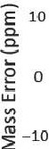

30

20

-20

I •

21 10'

C

I 20

**:E**

-

I= 19

5

**EE**

cg

10'

.?

107

18

0:

17

-30 16

10'

10'

rn'

mAb# 1 mAb#2 mAb#l mAb#2 mAb#l mAb#2

**B C**

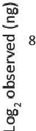

12

..

I

t:1 **t**• **-t**!**-+**• **T**I **-t**i

_,

**-f**♦

o

0 8 12

Log expected (ng)

2

**D**

-3

## 1-2. *U* 1-3

Injection replicates

#3 #4 #S

Technical replicates

* IMGT Fab distribution, n = 131,983,992

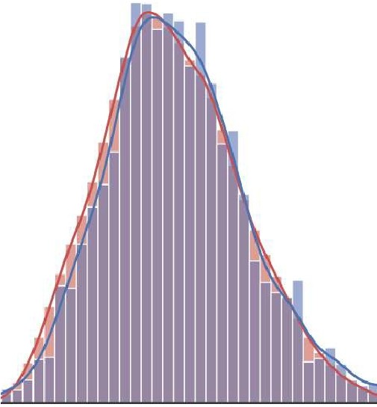

* All donors Fab distribution, n = S,593

r= 0.996

0.0004

-I

0 0.0003

0.0002

0.0001

0.0000 **L-_-...au**

45000 46000 47000 48000 49000

Mass(Da)

50000 51000 52000 53000

**Figure S1:** Figure Legend on next page.

**Figure S1: Performance evaluation of plasma Fab profiling approach using various experimental controls.** A) Accuracy and precision in mass, retention time and abundance of spiked-in monoclonal anti­ body controls. The boxplots show aggregated data from the mAb controls over all plasma measurements. The box indicates median and inter quartile ranges (IQRs), and the whiskers span 1.5 times the IQR. Values outside this range (fliers) are marked with diamonds. From left to right, the panels show observed mass error of these mAbs, observed retention time, and detected intensity. B) Linearity of detection. For these experiments six monoclonal antibodies (Trastuzumab, Cetuximab, Rituximab, Campath, Beva­ cizumab and lnfliximab) were added at 20, 200, 800 and 4000 ng in a plasma background. The detected response of all of these mAbs was compared to the expected response visualized as scatterplot. The error bars depict the standard error, and the dotted line shows an ordinary least squares (OLS) linear re­ gression accompanied by a R2. C) Reproducibility of quantitation. The reproducibility of the top 100 most intense clones in a plasma were measured over several replicates and visualized as boxplots. The values are shown as fold change of the concentration compared to the first replicate measurement. The first two boxplots depict injection replicates, i.e. replicates from multiple injections of the same sample. The other boxplots show technical replicates, which constitute the entire sample preparation procedure starting from the plasma. The boxes are constructed using the same method as the boxplots in panel (A). D) Distribu­ tions of detected Fab masses compared to the expected mass distribution. Kernel density estimation of all Fabs detected in all sepsis donors, at all analyzed time points, compared against an in silica generated distribution of Fabs from the IMGT database. The number of Fabs used to generate each distribution is shown in the figure legend. Both distribution histograms use a bin size of 100 Da. The Pearson correlation coefficient (r) was calculated between both kernel density estimations.

**3**

**A** 70 M66-T3

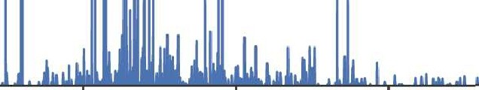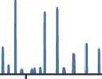

60

50

cg

i 40

C

.0,

g

fl 30

C

0u

20

10

46000 **47000** 48000 49000 50000 51000 **52000**

**B**

Mass (Da)

♦

♦

♦

■

■

■

♦

♦

**j A**

■

**l**

■.

*I*

**ft A I**

I

I

■

14

12

::; 10

l

C

0,:;

I!!

C

0u

**50600 50800 51000 51200 51400 51600 51800**

Mass (Da)

Estimated Fab glycosylation (%)

|  |  |  |  |  |  |  |  |  |  |
| --- | --- | --- | --- | --- | --- | --- | --- | --- | --- |
| **C** |  |  |  | | | | | | |
|  | Tl | 0.51 | **0.18** | 0.61 | 1.23 | 0.29 | 0.97 | 0.16 | 2.23 |
|  | T2 | 0.12 | 0.24 | 0.53 | 3.65 | 0.25 | 0.00 | 0.18 | 3.10 |
|  | T3 | 0.00 | 0.29 | 0.68 | 6.37 | 0.47 | 0.85 | 0.35 | 3.01 |
|  | T4 | 0.04 | 0.37 | 0.30 | 2.91 | 0.31 | 0.27 | 1.86 | 2.03 |
|  |  | F59 | F76 | M56 | M66 | M67 | **M69** | M75 | M77 |

|  |  |  |
| --- | --- | --- |
| **Ml** | 3.30 | 0.52 |
| M2 | 3.36 | 0.50 |
| M3 | 2.92 | 0.48 |
|  | F66H | M57H |

**Figure S2:** Figure Legend on next page.

**Figure S2: Extent of Fab glycosylation in the plasma repertoire** A) Fab mass profile of donor M66, taken from the plasma sample at time point 3. The mass range between 50,400 Da and 52,000 Da is boxed in red and shown magnified in panel (B). B) Zoomed-in mass profile with annotation of glycan­

related masses. Monosaccharides mass differences between peaks are annotated as follows: blue square

= GlcNAc (203 Da), magenta diamond = sialic acid (291 Da). For annotation of the glycosylation a mass

tolerance of 1 Da and a retention time tolerance of 0.6 min was used. C) Estimated percentages of plasma Fab molecules being glycosylated in all samples measured. For this, Fab clones with a mass

>49,500 Da were assumed to carry one or more Fab glycans. This value was chosen because the in silica

Fab distribution generated from the IMGT database (shown in **Figure S1D)** extends up to 49,500 Da, the majority of Fabs has a mass between 47,000 and 48,000, and the average literature described Fab glycan has a mass of approximately 2,300 Da. The validity of this assumption is illustrated for M66 - T3 in panels

(A) with the glycosylated Fabs being in mass quite separated from the other clones. The percentage of plasma Fab molecules being glycosylated was calculated by taking the sum of Fab concentrations above 49,500 Da and dividing these by the total detected concentration in each sample. On the left in C) are shown the % Fab glycosylation in the plasmas of the septic patients, on the right the % observed in two healthy donors. In general, we observe that the % Fab glycosylation is< 1%, although in some donors it is substantially higher, i.e. M66. M77 and F66H.

**3**

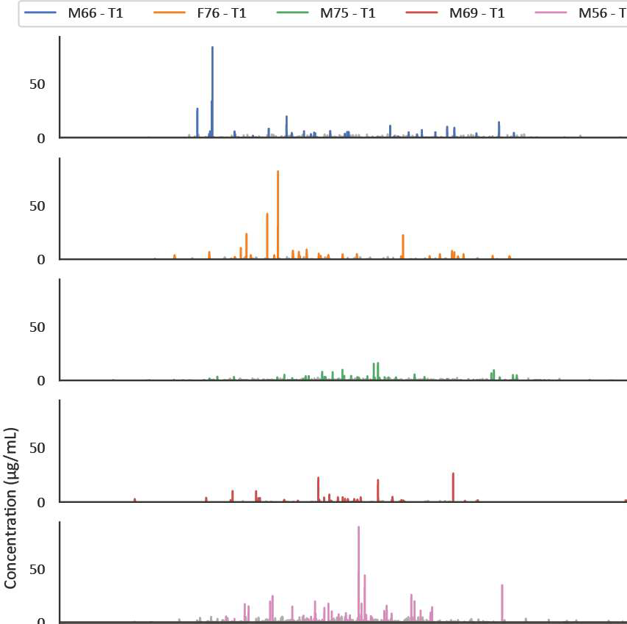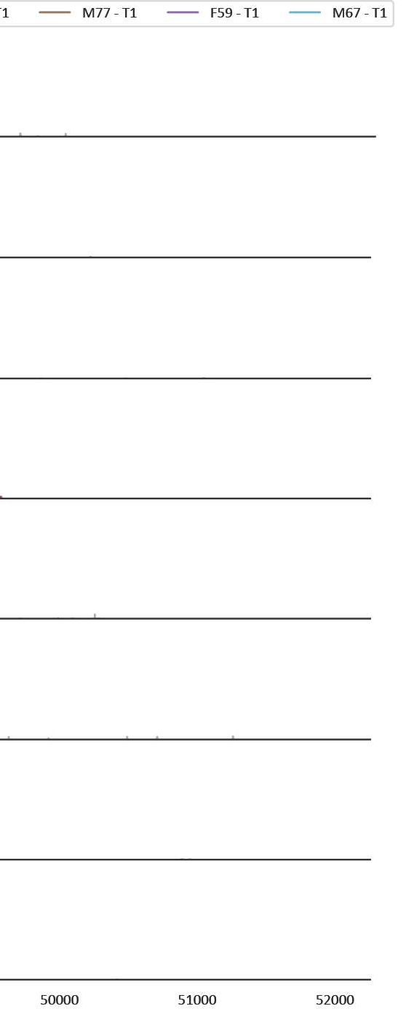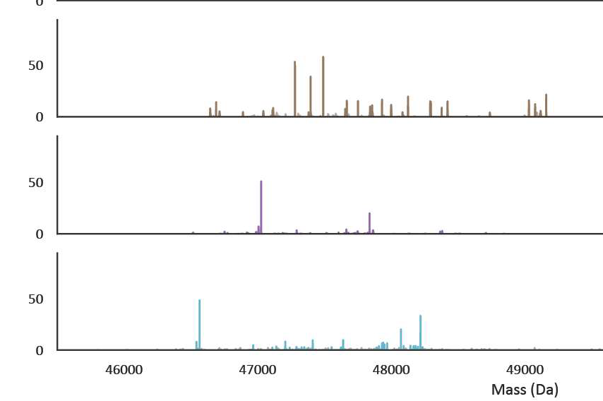

**3**

**Figure 53: Fab mass profiles are simple and uniquely individual.** The by LC-MS obtained Fab mass profiles are shown for plasma taken from each patient at time point 1 (post-operative). The Fab mass profiles are plotted along the full mass range. In each profile the top 30 most intense clones are colored, with a separate color for each donor. The remaining clones are shown in grey. The concentrations were determined from the LC-MS intensities, normalized against two spiked in recombinant mAbs.

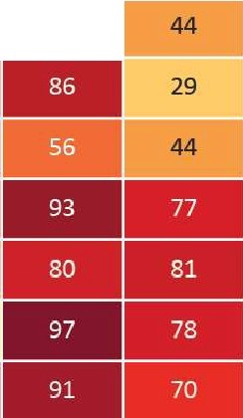M66 ....

■

■■

0% 50% **100%**

I

MO

F76 ....

M75 ..

**A B**

F66H

Ml

M ···

M69 ..

MS6 ..

M77 ..

MO 2 FS9 30

--

 M67 ..

M57H Ml 2 Tl-T2 T2-T3 T3-T4

M2 2

7 MO Ml M2 MO Ml M2 F66H M57H

**C** 1

F66H M57H

MO-Ml Ml-M2

* **F66HMO**
* **F66HM1**

*1*

]:

.0 ,C ,

l, **IL, b** .L

**ii I h •1** 1..

1. J

- **F66HM2**

1

**530**

***3***

**LI** iiJ

1 ***3***

E

1l

C

0u

**I L**-**1**

**LI** I•.

i1.J

46000 47000 48000 49000 S0000 **51000** S2000 53()()()

Mass (Da)

10001 - **M57HM0**

l I

800 - **M57HM1**

- **M57HM2**

Ji1

.I

11

f1001

**228**

£ **50**

**0**

*8* 10001

l I

800

i,li

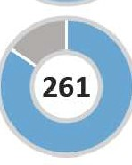J,I

**a**

46000 **47000** 48000 49000 S0000 51000 **s2000 530()()**

Mass (Da)

**Figure S4:** Figure Legend on next page.

**Figure 54: Longitudinal plasma Fab profiles obtained for two healthy donors.** A) Heatmap of healthy donors F66H and M57H constructed using the same method as used in **Figure 2A.** Time points are marked MO, 1, and 2, representing month 0, month 1 and month 2, to clearly distinguish these from the sepsis donor time points. Inside each cell of the heatmap a percentage value shows the degree of overlap between samples, which is also represented by the color bar. B) Heatmap showing the Fab overlap in consecutive time points of all healthy and sepsis affected donors, showing only the degree of overlap for consecutive time points within each donor. The colors match those of the color bar from panel A. C) Mass profiles of healthy donors with donut charts. For each mass profile the top 30 most intense clones are colored, and the remaining clones are colored grey. In the donut charts the colored slice displays the distribution of the top 30 most intense clones compared to the other clones. The value inside the donut shows the total number of detected clones.

**3**

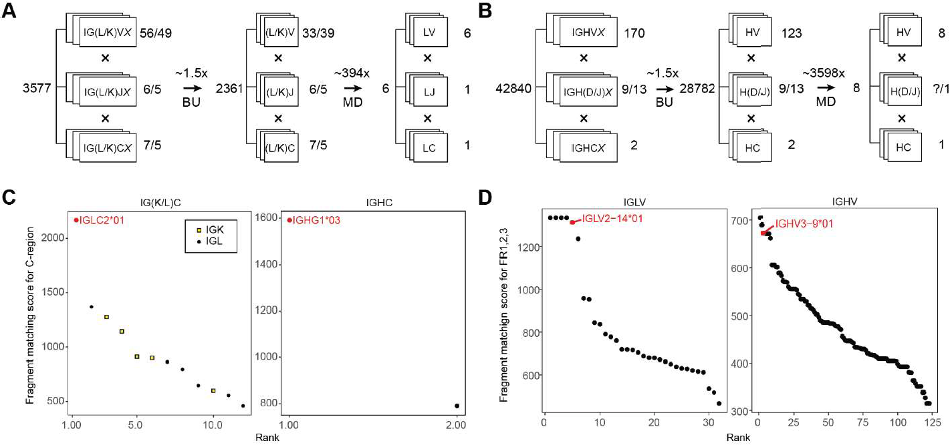

**Figure 55: Template matching of the obtained sequencing data for the Fab clone 24.4 1** 47359_4 **versus the IMGT database.** The filtering of IMGT database and scoring of the germline IGXV and IGXC-alleles was performed by using iteratively bottom-up (BU) and middle-down (MD) proteomics data. A) Filtering of

germline IGL and IGK alleles with BU and MD mass spectrometry (MS) reduces the number of possible germline light chain sequences from 3,577 to 6 candidate sequences (~600-fold reduction). B) Filtering of germline IGH alleles with BU MS and MD MS reduces the number of possible germline heavy chain sequences from 42,840 to 8 candidate sequences (~5,000-fold reduction). C) Fragment matching scores for the germline C-gene alleles of the light (left) and heavy (right) chain of the Fab clone 24.4 1 47359.4 using the middle-down MS data. D) Fragment matching scores for the Framework Regions 1, 2, and 3 of the germline V-gene alleles of light (left) and heavy (right) chains of lgG1 determined by using the middle-down MS data.

**3**

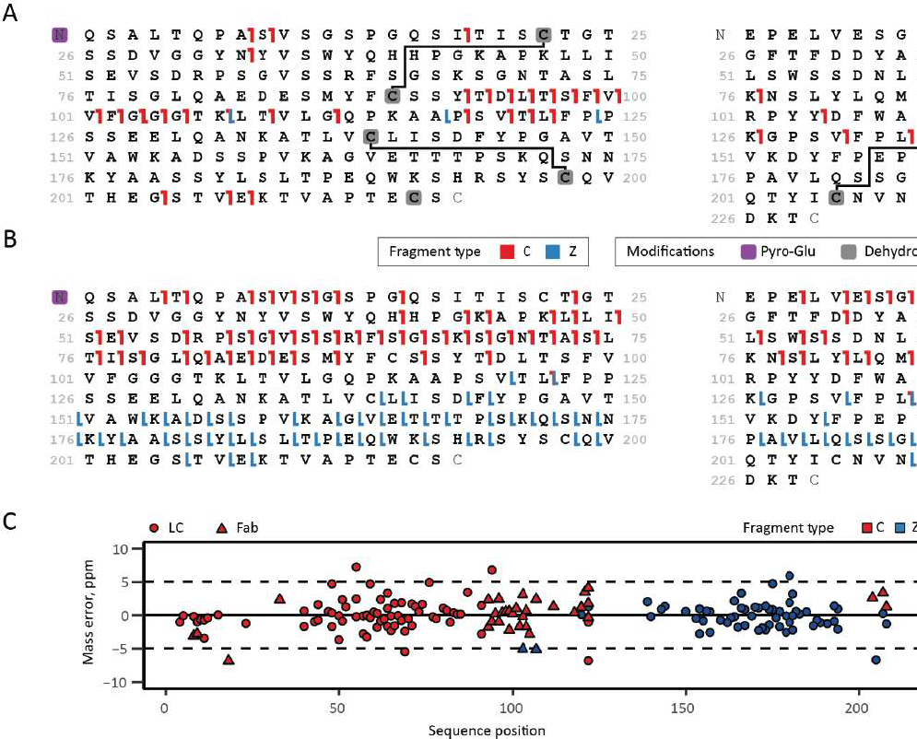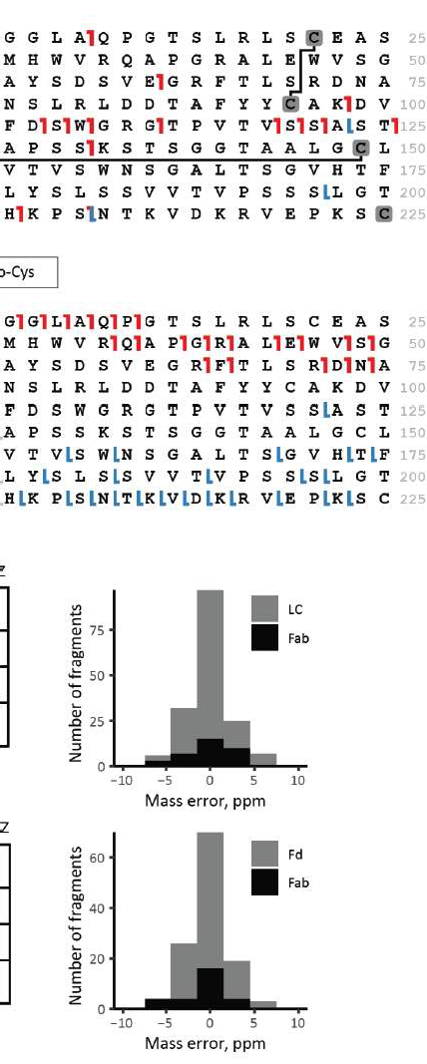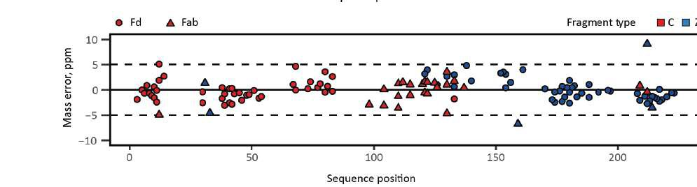

**Figure 56: Middle-down ETD analysis and sequence annotation of the light chain and the N­ terminal portion of the heavy chain from clone** 24·4 **1 47359.4 from donor F59.** A) Fragmentation maps of the light chain (left) and Fd (right) when subjected to ETD within the intact Fab molecule. B) Fragmen­

tation maps of the light chain (left) and Fd (right) when subjected to ETD after reduction and denaturation of the precursor Fab. C) Mass errors and their distribution of the light chain fragments observed in ETD of Fab and the light chain alone, and mass errors and distribution thereof for Fd fragments detected in ETD of Fab and Fd alone.

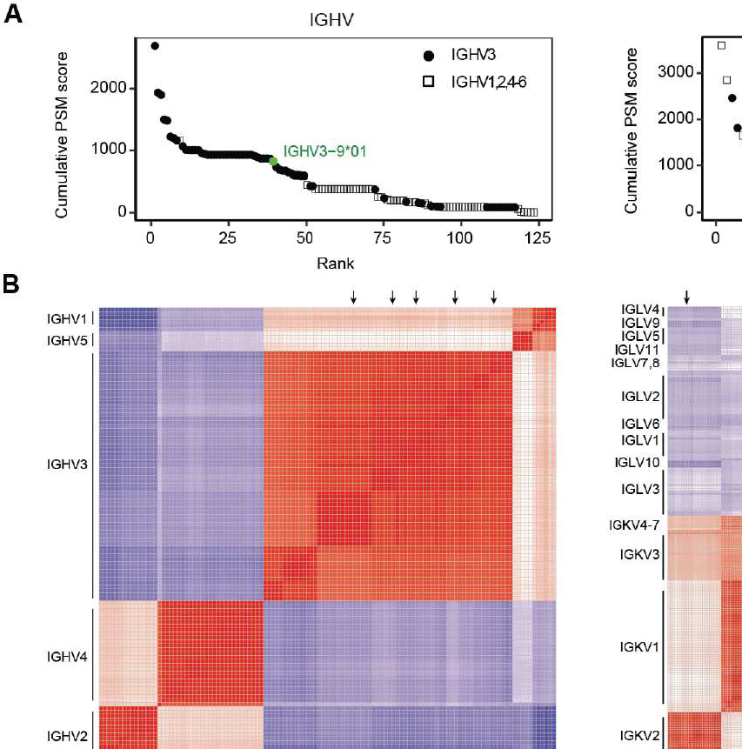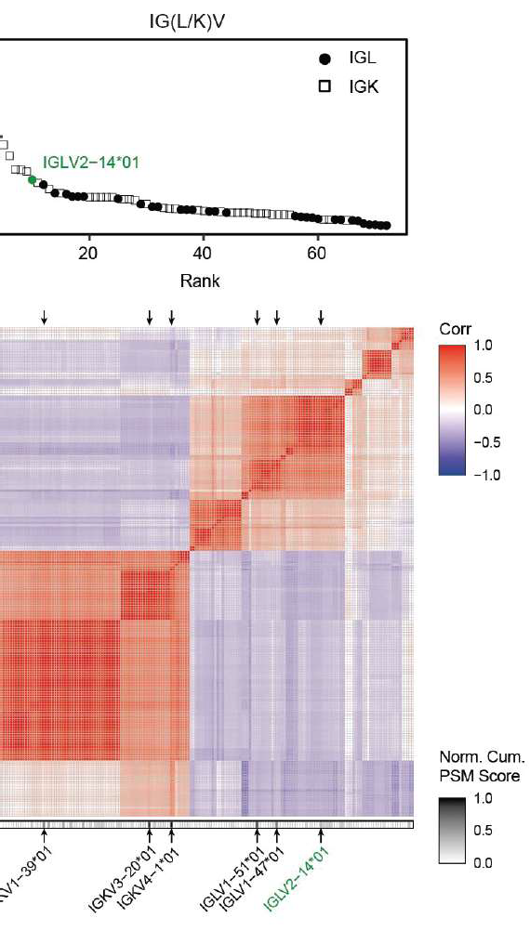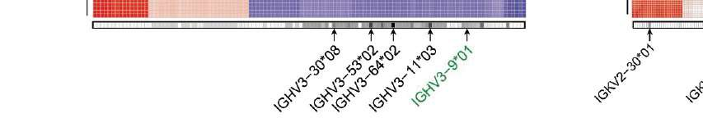

**3**

**Figure 57: Large homologous families of lg V-gene alleles (e.g. IGHV3) are observed among the top-scoring identifications as extracted from the bottom-up proteomics data.** A) Cumulative PSM scores determined for the germline V-gene alleles of the Fab heavy (left) and light chains (right). On the left, alleles from the largest IGHV3 family are displayed as filled circles; alleles of other IGHV families are shown as empty squares. On the right, alleles from larger and more homologous IGKV families are shown as empty squares, while filled circles display alleles of IGLV families. Germline V-gene sequences were downloaded from IMGT. B) Correlation matrix displaying sequence similarity among all germline V-gene sequences of the Fab heavy (left) and light (right) chain. Normalized cumulative PSM scores are shown

below the correlation maps. Some of the top-scoring V-gene sequences are indicated with black arrows. The V-genes ultimately determined for clone 24.4 1 47359.4 by the integrative *de nova* bottom-up and middle­ down sequencing are highlighted in green.

**3**

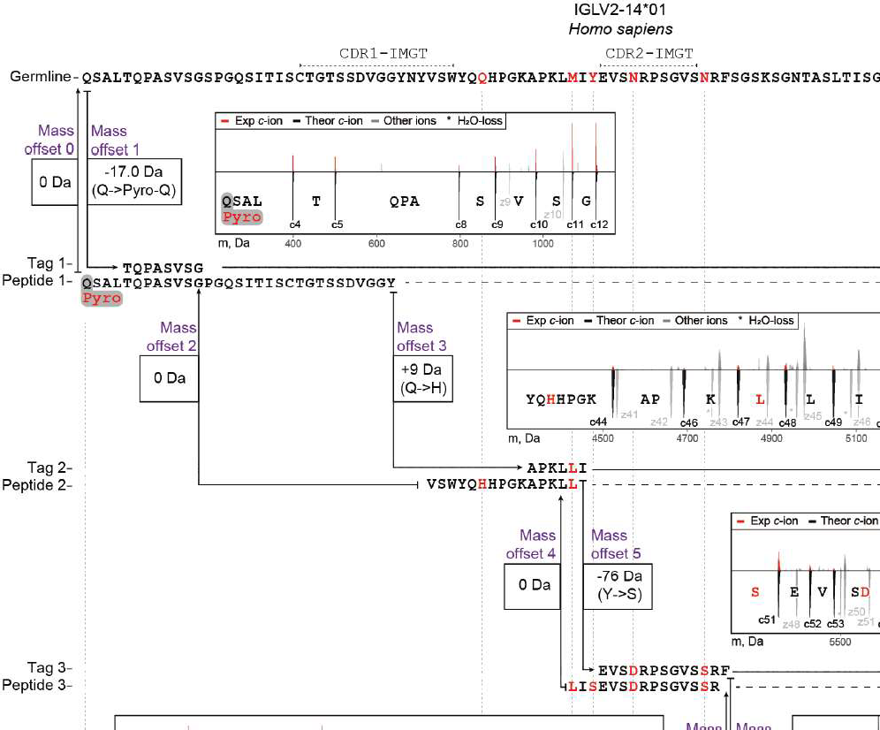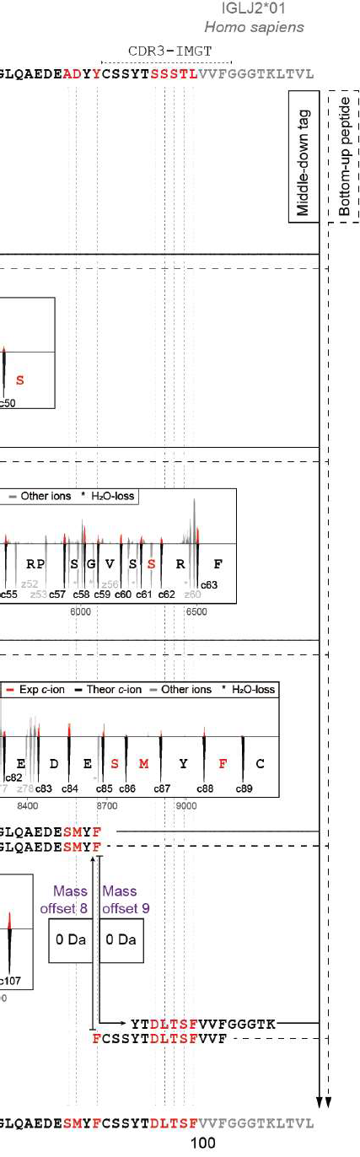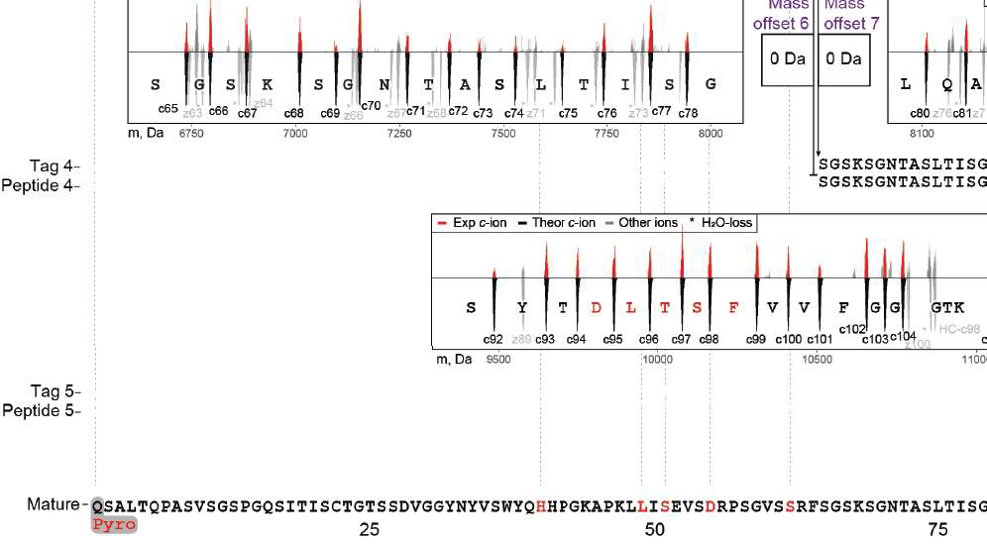

**Figure 58: Refining of the sequence of clone** 24.4 **1** 47359_4 **light chain germline IGLV2-14*01- IGLJ2*01, based on the iterative integration of middle-down and bottom-up proteomics data.** A) First, the sequence tags detected in the middle-down MS data were used as arrays of consecutive frag­ ment peaks, which directly hinted at the presence of 11 mutations (M49L, Y51S, Y51S, N55D, N62S, A85S, O86M, Y88F, S95D, S96L, S97T, T98S, and L99F). Next, these tags were aligned to the *de nova* sequenced peptide sequences obtained by bottom-up MS, revealing 2 additional mutations. The highest scoring aligned peptides were used to extend the initial sequence tags, and then these steps were iter­

atively repeated. At each step of tag extension, the mass offsets were calculated by comparing a mass gap between two consecutive tags to the mass of amino acid residues in the corresponding gap in the germline sequence. Iteratively, middle-down tags were extended with aligning peptides until all (if possi­ ble) mass offsets become equal to 0 Da. Eventually, 13 mutations and one modified residue (Pyro-Q) were determined for the 24.4 1 47359.4 light chain sequence. De-charged isotopic distributions of the fragments involved in each sequence tag are displayed as red peaks in the corresponding insets with the theoretical isotopic distributions for these fragments displayed underneath each fragment. Fragmentation spectra of the peptides used in this refining process for the CDRs are shown in **Figure 5.** See also **Table 55.** for an overview of the evidence supporting each detected amino acid mutation.

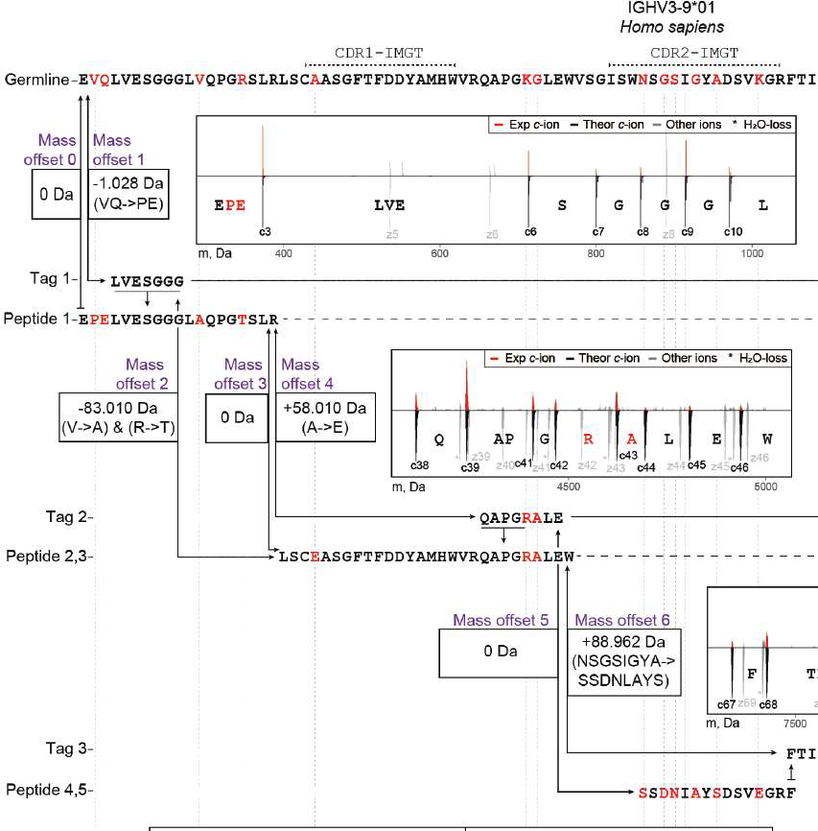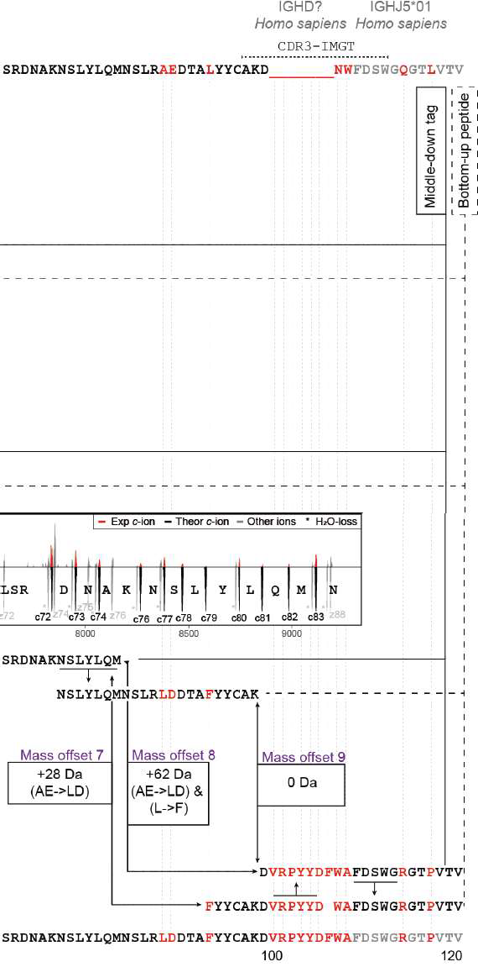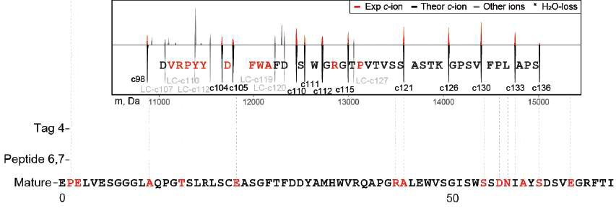

**3**

**Figure 59: Refining of the sequence of clone** 24·4 **1** 47359_4 **heavy chain germline IGHV3-9*01- IGHJ5*01, based on the iterative integration of middle-down and bottom-up proteomics data.** A) First, sequence tags were detected in the middle down MS data as arrays of consecutive fragment peaks similar to refining of the light chain. Next, these tags were aligned to the *de nova* sequenced peptides from bottom-up MS. The highest-scoring aligned peptides were used to extend the initial tags, and then

this step was repeated. At each step of tag extension, the mass offsets were calculated by comparing a mass gap between two consecutive tags to the mass of amino acid residues in the corresponding gap in the germline sequence. Iteratively, tags were extended with aligning peptides until all (if possible) mass offsets become equal to O Da. Eventually, more than 20 mutations were determined for the N-terminal portion of the heavy chain for clone 24.4 1 47359.4. De-charged isotopic distributions of the fragments in­ volved in each sequence tag are displayed as red peaks in the corresponding insets with the theoretical isotopic distributions for these fragments displayed underneath each fragment. Fragmentation spectra of the peptides used in this refining process for the CDRs are shown in **Figure 5.**

16

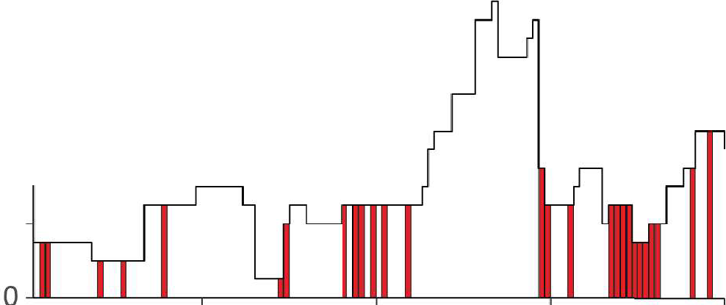

£ 12

0.. QJ "'O

* Mutation site

Heavy chain

8

.r.o..

u 4

30 60

Sequence position

Light chain

90 120

.

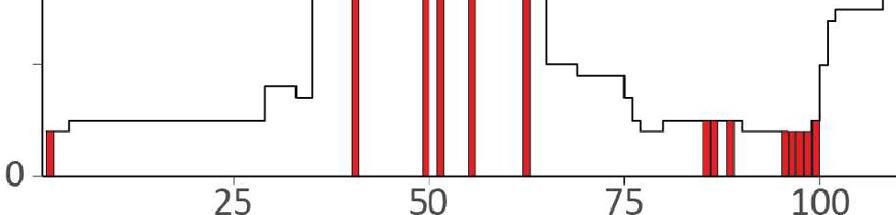

30 ■ Mutation site

c

+-'

0..

20

QJ

trloO

>

u0

a:i 10

Sequence position

**Figure S10: Coverage depths for *de novo* sequenced light and heavy chains of the clone** 24.4 **1** 47359_4 **from donor F59.** A) Values at each position represent the number of unique peptides identified in the bottom-up LC-MS/MS data. The determined mutation sites are depicted in red. Only the first 110 and 120 amino acids are shown for the light and heavy chain, respectively.

## References

1. Harry W. Schroeder. Similarity and divergence in the develop­ ment and expression of the mouse and human antibody reper­ toires. *Developmental and Comparative Immunology,* 30(12): 119-135, 2006. ISSN 0145305. doi: 10.1016lj.dci.2005.06.

006.

1. A lulian Apostoaei and John R Trabalka. Review, synthesis, and application of information on the human lymphatic system to radiation dosimetry for chronic lymphocytic leukemia final re­ port. 2012.
2. Bryan Briney, Anne lnderbitzin, Collin Joyce, and Dennis R. Burton. Commonality despite exceptional diversity in the base­ line human antibody repertoire. *Nature,* 566(7744):393-397, 2019. ISSN 1476-4687. doi: 10.1038ls41586-019-0879-y.
3. Cinque Soto, Robin G. Bombardi, Andre Branchizio, et al. High frequency of shared clonotypes in human b cell receptor reper­ toires. *Nature,* 566(7744):398-402, 2019. ISSN 14764687. doi: 10.1038ls41586-019-0934-8.
4. Davide Corti, John Misasi, Sabue Mulangu, et al. Protective monotherapy against lethal ebola virus infection by a potently neutralizing antibody. *Science (New York, N.Y.),* 351(6279): 1339--1342, 2016. ISSN 1095-9203. doi: 10.1126lscience.

aad5224.

1. Owen Dyer. Two ebola treatments halve deaths in trial in drc outbreak. *BMJ (Clinical research ed.),* 366:5140, 2019. ISSN 17561833. doi: 10.1136lbmj.15140.
2. Sabue Mulangu, Lori E. Dodd, Richard T. Davey, et al. A ran­ domized, controlled trial of ebola virus disease therapeutics. *New England Journal of Medicine,* 381(24):2293-2303, 2019. ISSN 0028-4793. doi: 10.1056lnejmoa1910993.
3. Bryan E. Jones, Patricia L. Brown-Augsburger, Kizzmekia S. Corbett, et al. The neutralizing antibody, ly-cov555, protects against sars-cov-2 infection in nonhuman primates. *Science Translational Medicine,* 13(593), 2021. ISSN 19466242. doi: 10.1126/scitranslmed.abf1906.
4. George Georgiou, Gregory C. Ippolito, John Beausang, et al.

The promise and challenge of high-throughput sequencing of the antibody repertoire. *Nature Biotechnology,* 32(2):158-168, 2014. ISSN 10870156. doi: 10.1038/nbt.2782.

1. Christopher Vollmers, V. Rene Sit, Joshua A. Weinstein, Cor­ nelia L. Dekker, and Stephen R. Quake. Genetic measurement of memory b-cell recall using antibody repertoire sequenc­

ing. *Proceedings of the National Academy of Sciences of the United States of America,* 110(33):13463-13468, 2013. ISSN 00278424. doi: 10.1073/pnas.1312146110.

1. James T. Cassidy and Gordon L. Nordby. Human serum im­

munoglobulin concentrations: Prevalence of immunoglobulin deficiencies. *The Journal of Allergy and Clinical Immunol­ ogy,* 55(1):35-48, 1975. ISSN 00916749. doi: 10.1016/

3

s0091-6749(75)80006-6.

1. A. Gonzalez-Quintela, R. Alende, F. Gude, et al. Serum levels of immunoglobulins (igg, iga, igm) in a general adult popula­ tion and their relationship with alcohol consumption, smoking and common metabolic abnormalities. *Clinical and Experimen­ tal Immunology,* 151(1):42-50, 2008. ISSN 00099104. doi: 10.1111lj.1365-2249.2007.03545.x.
2. Marijke Van Der Giessen, Emmerentia Rossouw, Tineke Algra­ Van Veen, et al. Quantification of igg subclasses in sera of nor­ mal adults and healthy children between 4 and 12 years of age. *Clin. exp. lmmunol,* 21:501-509, 1975.
3. Jing Chen, Qi Zheng, Christoph M. Hammers, et al. Proteomic analysis of pemphigus autoantibodies indicates a larger, more diverse, and more dynamic repertoire than determined by b cell genetics. Ce// *Reports,* 18(1):237-247, 2017. ISSN 22111247. doi: 10.1016/j.celrep.2016.12.013.
4. Jason J. Lavinder, Yariv Wine, Claudia Giesecke, et al. Iden­ tification and characterization of the constituent human serum antibodies elicited by vaccination. *Proceedings of the National Academy of Sciences,* 111(6):2259--2264, 2014. ISSN 0027-

8424. doi: 10.1073/pnas.1317793111.

1. Jiwon Lee, Daniel R. Bautz, Veronika Chromikova, et al.

Molecular-level analysis of the serum antibody repertoire in young adults before and after seasonal influenza vaccination. *Nature Medicine,* 22(12):1456-1464, 2016. ISSN 1546170. doi: 10.1038/nm.4224.

(17] Jiwon Lee, Philipp Paparoditis, Andrew P. Horton, et al. Per­ sistent antibody clonotypes dominate the serum response to influenza over multiple years and repeated vaccinations. *Cell Host and Microbe,* 25(3):367-3765, 2019. ISSN 19313128. doi:

10.1016/j.chom.2019.01.010.

[18] Yariv Wine, Daniel R. Bautz, Jason J. Lavinder, et al. Molec­ ular deconvolution of the monoclonal antibodies that comprise the polyclonal serum response. *Proceedings of the National Academy of Sciences of the United States of America,* 110 (8):2993-2998, 2013. ISSN 00278424. doi: 10.1073/pnas.

3

1213737110.

(19] David R. Bamidge, Surendra Dasari, Marina Ramirez­ Alvarado, et al. Phenotyping polyclonal kappa and lambda light

(24] Faye A. Sharpley, Richa Manwani, Shameem Mahmood, et al. A novel mass spectrometry method to identify the serum mon­ oclonal light chain component in systemic light chain amyloido­ sis. *Blood Cancer Journal,* 9(2):16, 2019. ISSN 2044-5385. doi: 10.1038/s41408-019-0180-1.

1. Zhe Wang, Xiaowen Liu, Jennifer Muther, et al. Top-down mass spectrometry analysis of human serum autoantibody antigen­ binding fragments. *Scientific reports,* 9(1):2345, 2019. ISSN 2045-2322. doi: 10.1038/s41598-018-38380-y.
2. Christian Spoerry, Pontus Hessle, Melanie J. Lewis, et al.

Novel igg-degrading enzymes of the igde protease family link substrate specificity to host tropism of streptococcus species. *PLoS ONE,* 11(10), 2016. ISSN 19326203. doi: 10.1371/

chain molecular mass distributions in patient serum using mass journal.pone.0164809.

spectrometry. *Journal of Proteome Research,* 13(11):5198- [27] Marie Paule Lefranc, Veronique Giudicelli, Chantal Ginestoux, 5205, 2014. ISSN 15353907. doi: 10.1021/pr5005967. et al. lmgt, the international immunogenetics database. *Nucleic*

(20] David R. Bamidge, Surendra Dasari, Chad M. Botz, et al. Us- *Acids Research,* 27(1):209-212, 1999. ISSN 03051048. doi: ing mass spectrometry to monitor monoclonal immunoglobulins 10.1093/nar/27.1.209.

in patients with a monoclonal gammopathy. *Journal of Pro-* [28] Albert Bondt, Manfred Wuhrer, T. Martijn Kuijper, Jo- *teome Research,* 13(3):1419-1427, 2014. ISSN 15353893. hanna M.W. Hazes, and Radboud J.E.M. Dolhain. Fab gly- doi: 10.1021/pr400985k. cosylation of immunoglobulin g does not associate with im-

[21] Lidong He, Lissa C. Anderson, David R. Bamidge, et al. Classi- provement of rheumatoid arthritis during pregnancy. *Arthritis* fication of plasma cell disorders by 21 tesla fouriertransform ion *Research and Therapy,* 18(1), 2016. ISSN 14786362. doi: cyclotron resonance top-down and middle-down ms/ms analy- 10.1186/s13075-016-1172-1.

sis of monoclonal immunoglobulin light chains in human serum. [29] Lise Hafkenscheid, Albert Bandt, Hans U. Scherer, et al.

*Analytical Chemistry,* 91(5):3263-3269, 2019. ISSN 0003-

2700. doi: 10.1021/acs.analchem.8b03294.

(22] Lidong He, Lissa C. Anderson, David R. Barnidge, et al. Anal­ ysis of monoclonal antibodies in human serum as a model for clinical monoclonal gammopathy by use of 21 tesla ft-icr top-

Structural analysis of variable domain glycosylation of anti­ citrullinated protein antibodies in rheumatoid arthritis reveals the presence of highly sialylated glycans. *Molecular and Cel­ lular Proteomics,* 16(2):278-287, 2017. ISSN 15359484. doi: 10.1074/mcp.m116.062919.

down and middle-down ms/ms. *Journal of the American Soci-* [30] Adrian Guthals, Yutian Gan, Laura Murray, et al. De nova *ety for Mass Spectrometry,* 28(5):827-838, 2017. ISSN 1044- ms/ms sequencing of native human antibodies. *Journal of Pro-* 0305. doi: 10.1007/s13361-017-1602-6. teome *Research,* 16(1):45-54, 2017. ISSN 1535-3893. doi:

(23] John R. Mills, David R. Bamidge, and David L. Murray. Detect- 10.1021/acs.jproteome.6b00608.

ing monoclonal immunoglobulins in human serum using mass [31] K. liker Sen, Wilfred H Tang, Shruti Nayak, et al. Automated spectrometry. *Methods,* 81:56-65, 2015. ISSN 10462023. doi: antibody de nova sequencing and its utility in biopharmaceu- 10.1016/j.ymeth.2015.04.020. tical discovery. *Journal of the American Society for Mass Spectrometry,* 28(5):803-810, 2017. ISSN 1879-1123. doi:

10.1007/s13361-016-1580-0.

(32] Ngoc Hieu Tran, M Ziaur Rahman, Lin He, et al. Complete de nova assembly of monoclonal antibody sequences. *Sci­ entific Reports,* 6(1):31730, 2016. ISSN 2045-2322. doi: 10.1038lsrep31730.

(33] Maurits A. den Boer, Jean-Francois Greisch, Sem Tamara, Al­ bert Bondi, and Albert J. R. Heck. Selectivity over coverage in de nova sequencing of iggs. *Chemical science,* 11(43):11886- 11896, 2020. ISSN 2041-6520. doi: 10.1039ld0sc03438j.

(34] Luca Fornelli, Daniel Ayoub, Konstantin Aizikov, et al. Top­ down analysis of immunoglobulin g isotypes 1 and 2 with elec­ tron transfer dissociation on a high-field orbitrap mass spec­ trometer. *Journal of proteomics,* 159:67-76, 2017. ISSN 1876-

7737. doi: 10.1016lj.jprot.2017.02.013.

(35] Jared B. Shaw, Weijing Liu, V. Yury Vasilev, et al. Direct de­ termination of antibody chain pairing by top-down and middle­ down mass spectrometry using electron capture dissociation and ultraviolet photodissociation. *Analytical chemistry,* 92(1): 766-773, 2020. ISSN 1520-6882. doi: 10.1021lacs.analchem.

9b03129.

(36] Weiwei Peng, Matti F. Pronker, and Joos! Snijder. Mass spectrometry-based de nova sequencing of monoclonal an­ tibodies using multiple proteases and a dual fragmentation scheme. *Journal of Proteome Research,* 20(7):3559--3566, 2021. ISSN 1535-3893. doi: 10.1021lacs.jproteome.1c00169.

(37] Kazutaka Kitaura, Hiroshi Yamashita, Hitomi Ayabe, et al. Different somatic hypermutation levels among antibody sub­ classes disclosed by a new next-generation sequencing-based antibody repertoire analysis. *Frontiers in immunology,* 8(May): 389, 2017. ISSN 1664-3224. doi: 10.3389/fimmu.2017.00389.

(38] La Tonya D. Williams, Gilad Ofek, Sebastian Schatzle, et al. Potent and broad hiv-neutralizing antibodies in memory b cells and plasma. *Science Immunology,* 2(7), 2017. ISSN 24709468. doi: 10.1126lsciimmunol.aal2200.

(39] A. Morell, W. D. Terry, and T. A. Waldmann. Metabolic prop­ erties of igg subclasses in man. *The Journal of clinical inves­ tigation,* 49(4):673-680, 1970. ISSN 00219738. doi: 10.11721 jci106279.

(40] Isaac R. Melamed, Michael Barte, Laurenz Trawnicek, et al. Pharmacokinetics of a novel human intravenous immunoglob­ ulin 10patients with primary immunodeficiency diseases: Anal­ ysis of a phase iii, multicentre, prospeclive, open-label study. *European Journal of Pharmaceutical Sciences,* 118:80-86, 2018. ISSN 18790720. doi: 10.1016lj.ejps.2018.03.007.

[41] Nadia L. Bernasconi, Elisabetta Traggiai, and Antonio Lanza­ vecchia. Maintenance of serological memory by polyclonal ac­ tivation of human memory b cells. *Science,* 298(5601):2199- 2202, 2002. ISSN 00368075. doi: 10.1126lscience.1076071.

3

(42] Rudolf A. Manz, Andreas Thiel, and Andreas Radbruch. Life­ time of plasma cells in the bone marrow (3]. *Nature,* 388(6638): 133-134, 1997. ISSN 00280836. doi: 10.1038140540.

(43] Mark K. Slifka, Rustom Antia, Jason K. Whitmire, and Rafi Ahmed. Humeral immunity due to long-lived plasma cells. *Im­ munity,* 8(3):363-372, 1998. ISSN 10747613. doi: 10.10161 s1074-7613(00)80541-5.

(44] Abdellah Tebani, Anders Gummesson, Wen Zhong, et al. Inte­ gration of molecular profiles in a longitudinal wellness profiling cohort. *Nature Communications,* 11(1), 2020. ISSN 20411723. doi: 10.1038ls41467-020-18148-7.

(45] Peter M.C.Klein Klouwenberg, David S.Y. Ong, Lieuwe D.J. Bos, et al. lnterobserver agreement of centers for disease con­ trol and prevention criteria for classifying infections in critically ill patients. *Critical Care Medicine,* 41(10):2373-2378, 2013. ISSN 00903493. doi: 10.1097lccm.Ob013e3182923712.

1. Mervyn Singer, Clifford S. Deutschman, Christopherwarren Seymour, et al. The third international consensus definitions for sepsis and septic shock (sepsis-3). *JAMA* - *Journal of the American Medical Association,* 315(8):801-810, 2016. ISSN

15383598. doi: 10.1001ljama.2016.0287.

1. Albert Bandt, Yoann Rombouts, Maurice H.J. Selman, et al. lmmunoglobulin g (igg) tab glycosylation analysis using a new mass spectrometric high-throughput profiling method reveals pregnancy-associated changes. *Molecular and Cellular Pro­ teomics,* 13(11):3029-3039, 2014. ISSN 15359484. doi: 10.1074lmcp.m114.039537.

(48] Manuela Amez Martin, Manfred Wuhrer, and David Falck. Serum and plasma immunoglobulin g fc n-glycosylation is sta­ ble during storage. *Journal of Proteome Research,* 20(5):2935- 2941, 2021. ISSN 15353907. doi: 10.1021/acs.jproteome. 1c00148.

[49] Michiel Van De Waterbeemd, Sem Tamara, Kyle L. Fort, et al.

Dissecting ribosomal particles throughout the kingdoms of life using advanced hybrid mass spectrometry methods. *Nature Communications,* 9(1), 2018. ISSN 20411723. doi: 10.1038/ s41467-018-04853-x.

(50] Wes McKinney. Data structures for statistical computing in python. *Proceedings of the 9th Python in Science Conference,* pages 56-61, 2010. doi: 10.25080/majora-92bf1922-00a.

[51] Stefan Van Der Walt, S. Chris Colbert, and Gael Varoquaux.

The numpy array: A structure for efficient numerical compu­ tation. *Computing in Science and Engineering,* 13(2):22-30, 2011. ISSN 15219615. doi: 10.1109/mcse.2011.37.

(52] Pauli Virtanen, Ralf Gommers, Travis E. Oliphant, et al. Scipy 1.0: fundamental algorithms for scientific computing in python. *Nature Methods,* 17(3):261-272, 2020. ISSN 15487105. doi: 10.1038/s41592-019-0686-2.

(53] John D. Hunter. Matplotlib: A 2d graphics environment. Com­ *puting in Science and Engineering,* 9(3):90-95, 2007. ISSN 15219615. doi: 10.1109/mcse.2007.55.

(54] Vlad Zabrouskov, Michael W. Senko, Yi Du, Richard D. Leduc, and Neil L. Kelleher. New and automated msn approaches for top-down identification of modified proteins. *Journal of the American Society for Mass Spectrometry,* 16(12):2027-2038, 2005. ISSN 10440305. doi: 10.1016/j.jasms.2005.08.004.

(55] T. F. Smith and M. S. Waterman. Identification of common

molecular subsequences. *Journal of Molecular Biology,* 147(1): 195--197, 1981. ISSN 00222836. doi: 10.1016/0022-2836(81)

90087-5.

(56] David L. Tabb, Ma Ze-Qiang, Daniel B. Martin, Amy Joan L. Ham, and Matthew C. Chambers. Directag: Accurate se­ quence tags from peptide ms/ms through statistical scoring. *Journal of Proteome Research,* 7(9):3838-3846, 2008. ISSN 15353893. doi: 10.1021/pr800154p.

(57] Mark B. Swindells, Craig T. Porter, Matthew Couch, et al.

abysis: Integrated antibody sequence and structure­ management, analysis, and prediction. *Journal of Molecular Biology,* 429(3):356-364, 2017. ISSN 10898638. doi: 10.1016/j.jmb.2016.08.019.



